**BROKEN ACCESS CONTROL**

**(Horizontal** privilege escalation vulnerability)

**Description-**

It includes unauthorized access, that allow an attacker to gain access to other accounts with the same or similar privileges.

Impact-

privacy concern, exploiting the vulnerability

Reference: -

[Access control vulnerabilities and privilege escalation | Web Security Academy (portswigger.net)](https://portswigger.net/web-security/access-control)

[What is Privilege Escalation? - CrowdStrike](https://www.crowdstrike.com/cybersecurity-101/privilege-escalation/)

POC-

**Step1):** **Open PortSwiggerLab – user ID controlled by request parameter**

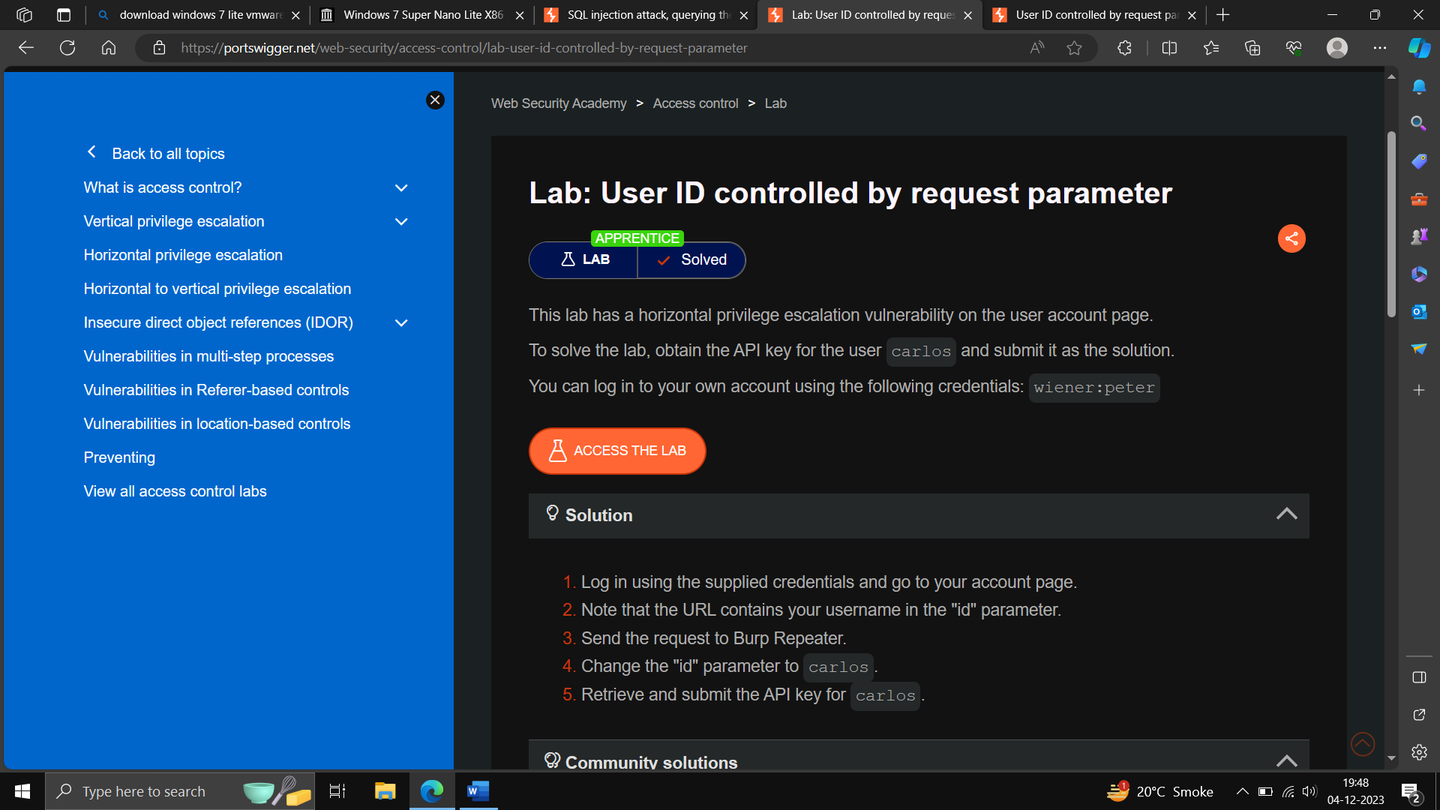

**Step2):** Click on my Account after access the lab and try login through Given Credential (wiener: peter)

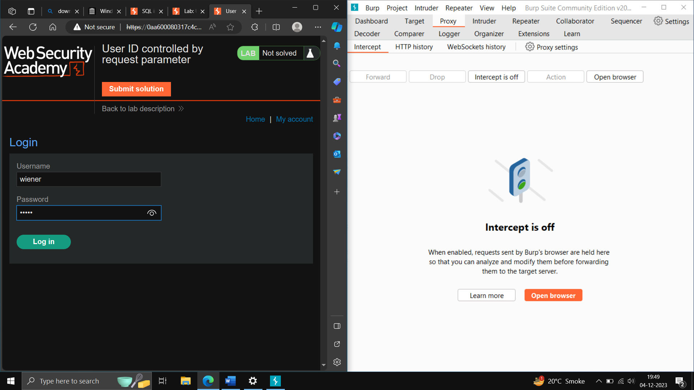

**Step3)**: Start Intercepting the traffic from burp suite and press login an then forward the request to login page

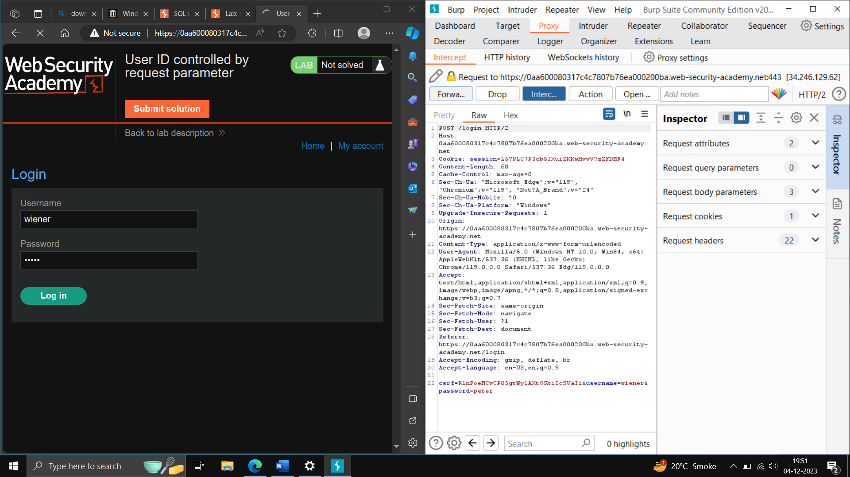

-**Step4):** The page still on same page and request the account id = wiener, manipulate the id to carlos and forward the request.

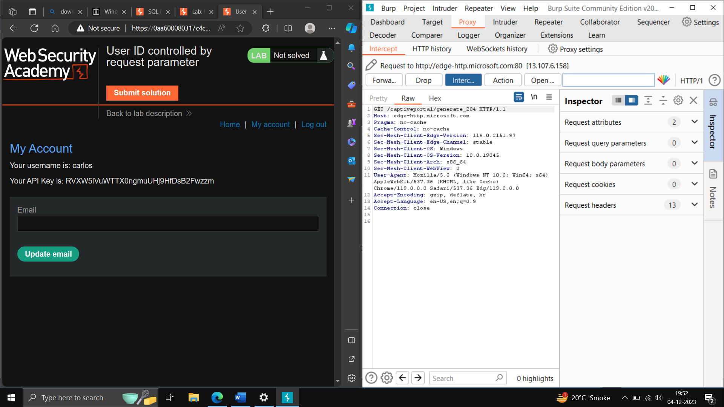

You can see the Carlos API Key.

**Step5-)**: Then Submit the solution.

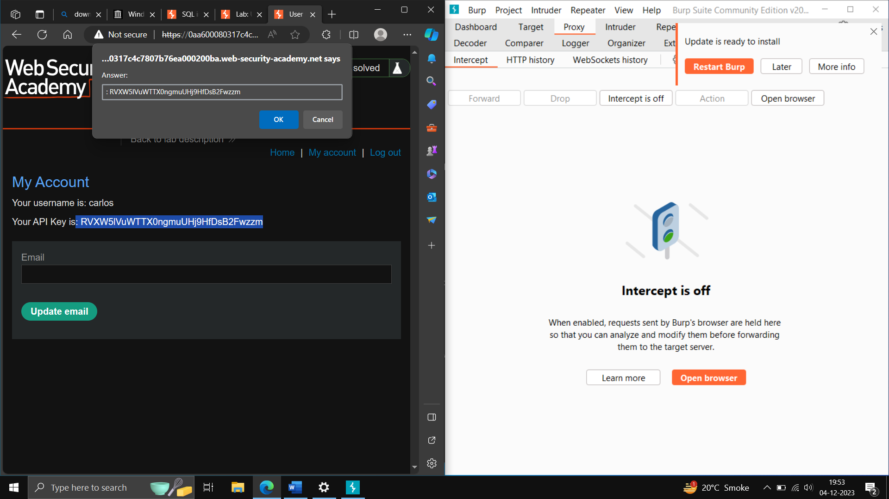

**BROKEN ACCESS CONTROL**

**(Vertical** privilege escalation vulnerability)

**Description –**

It includes unauthorized access, that allow an attacker to gain access to admin account.

Impact – Access Admin access, can delete the employee account

References-

Same as Above

POC –

## Step1): – Open the PortSwigger Lab - Unprotected admin functionality

## 

-Click Access the Lab.

**Step2)**: after landing the Page, edit the URL and add robots.txt at the end of URL –

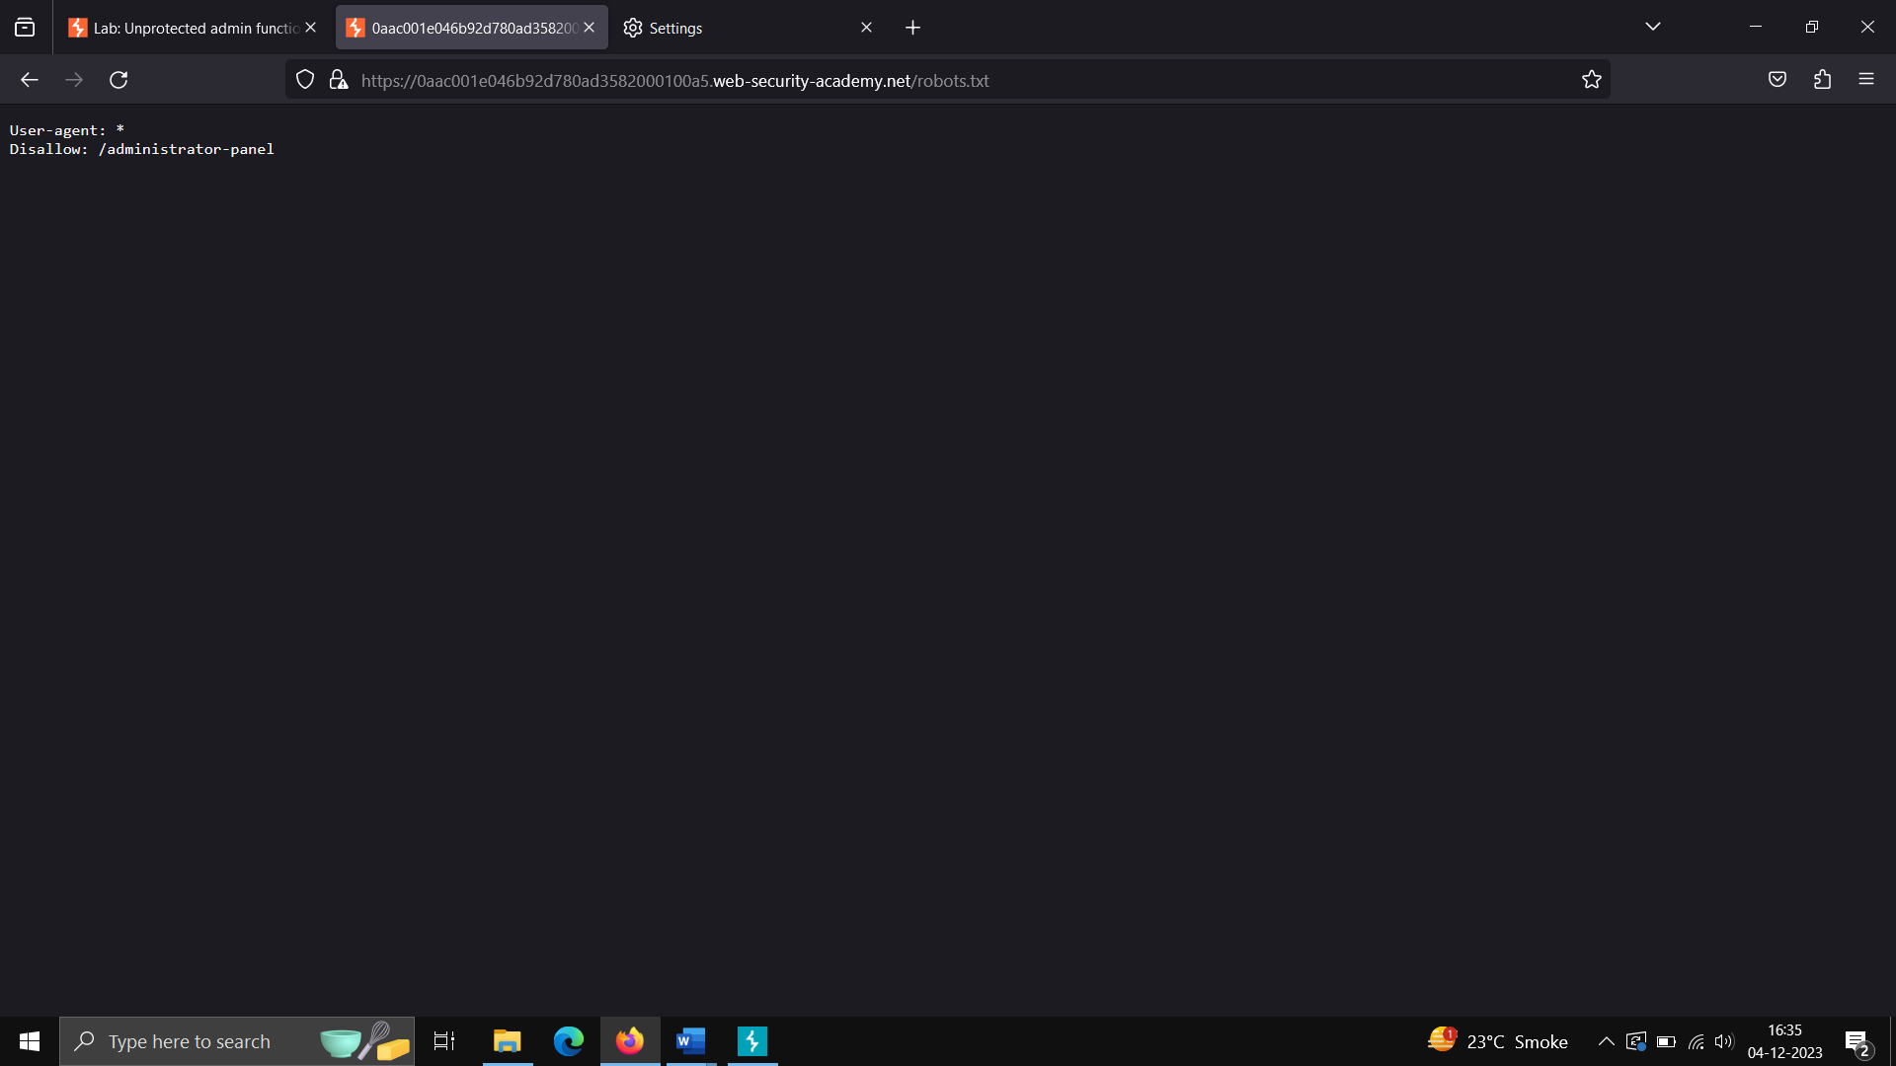

**Step3)**:– edit the URL to below mentioned and access the admin account

<https://0aac001e046b92d780ad3582000100a5.web-security-academy.net/administrator-panel>

after that delete the Carlos account –

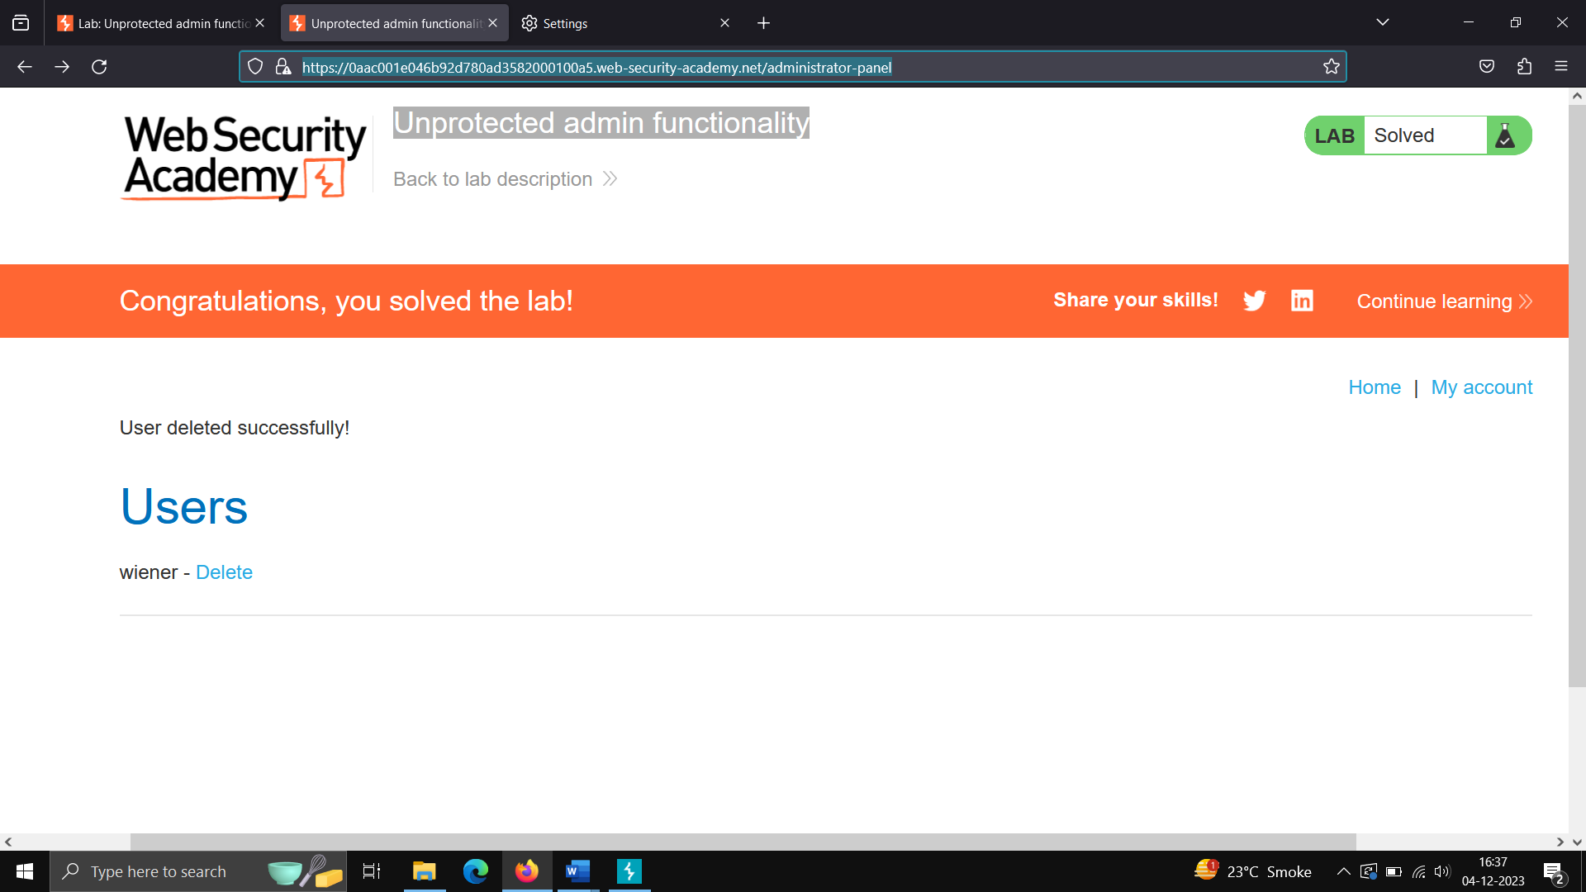

**Lab2.1) - Information Disclosure in error Messages**

Step1)- Open Website -> Open Burp Suite-> Reload the Website -> Check Burp Suite History

Step2) – Click on any options in the Website, check in Intercept request -> right click the request send to repeater

Step3) – In repeater, request showing some ID ex- id=1 -> change id to “Hacker” -> click on Send Button,

Step4) – Check the response, some error message displays Apache Struts Version

Step5) – Copy the server Version -> go on website, click on submit button, paste the Version.

**-Cryptographic Failure**

A cryptographic failure is a critical **web application security vulnerability** that exposes sensitive application data on a weak or non-existent cryptographic algorithm. Those can be passwords, patient health records, business secrets, credit card information, email addresses, or other personal user information.

**Impact-**

[Attackers can get hold of a complete database having thousands of sensitive information, data theft, public listing, breaches, and many critical problems with business-related data](https://www.bing.com/ck/a?!&&p=40681c61c2db6e7dJmltdHM9MTcwMTczNDQwMCZpZ3VpZD0wZDEyODk5Ny05MTA2LTY0MDEtMzllNS05YWRiOTAwMDY1Y2MmaW5zaWQ9NTc1NQ&ptn=3&ver=2&hsh=3&fclid=0d128997-9106-6401-39e5-9adb900065cc&psq=cryptographic+failure+impact&u=a1aHR0cHM6Ly93d3cuc29mdHdhcmVzZWN1cmVkLmNvbS9pbnRyb2R1Y3Rpb24tdG8tY3J5cHRvZ3JhcGhpYy1mYWlsdXJlcy8&ntb=1).

**References:**

[A02 Cryptographic Failures - OWASP Top 10:2021](https://owasp.org/Top10/A02_2021-Cryptographic_Failures/)

[Cryptographic Failures Vulnerability - Examples & Prevention (crashtest-security.com)](https://crashtest-security.com/owasp-cryptographic-failures/)

**Severity: HIGH**

**POC –**

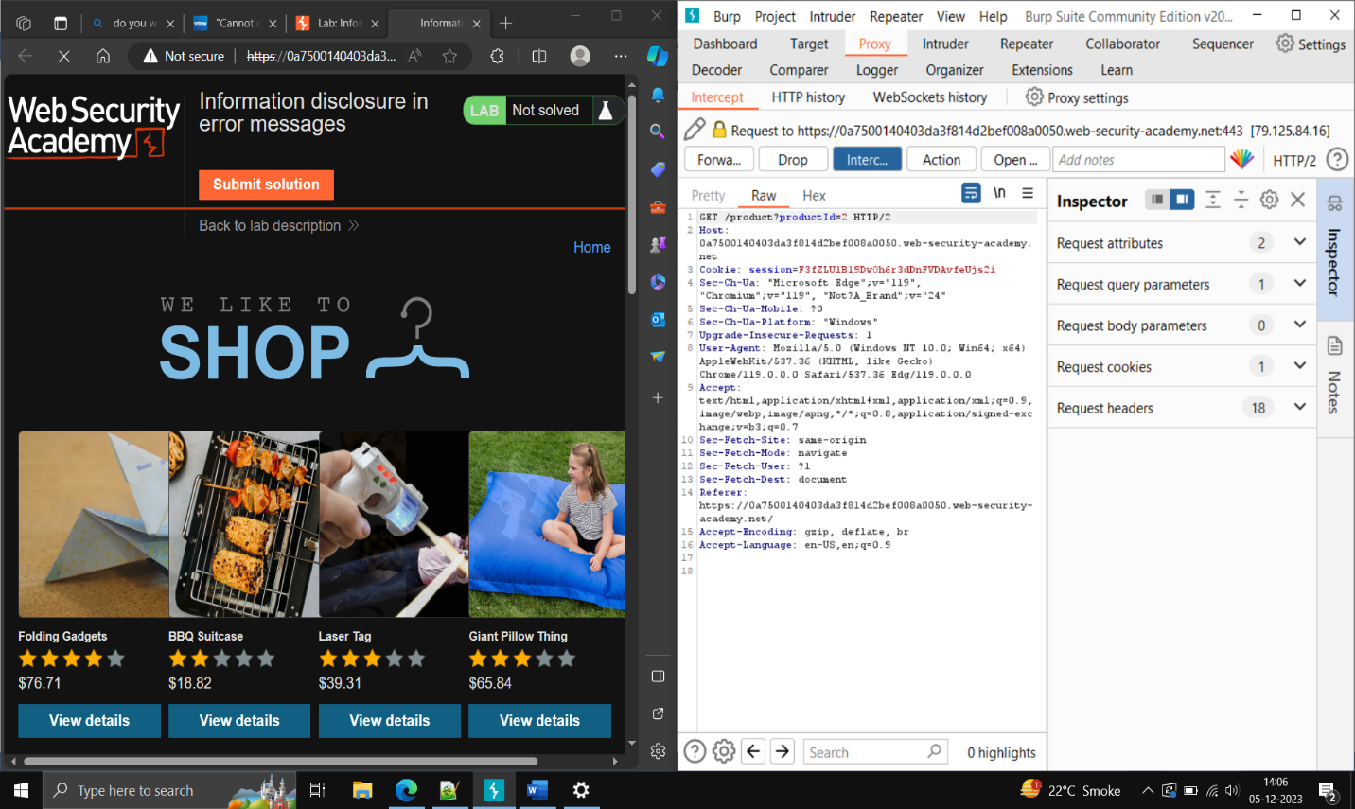**Step1) -** On the Website Click on any product and check the request in intercept Tab.

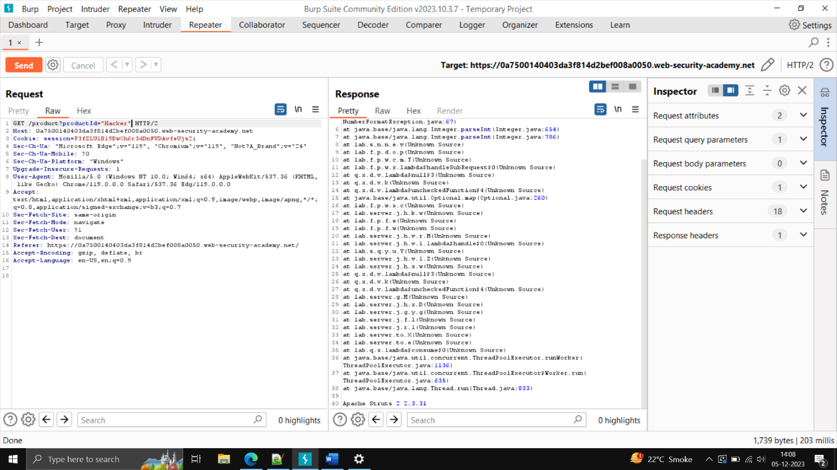Step2) Send the request to Repeater and manipulate the Id to String ->” hacker”

And then check the response as above.

Step3)- Finally submit the Solution on the Website.

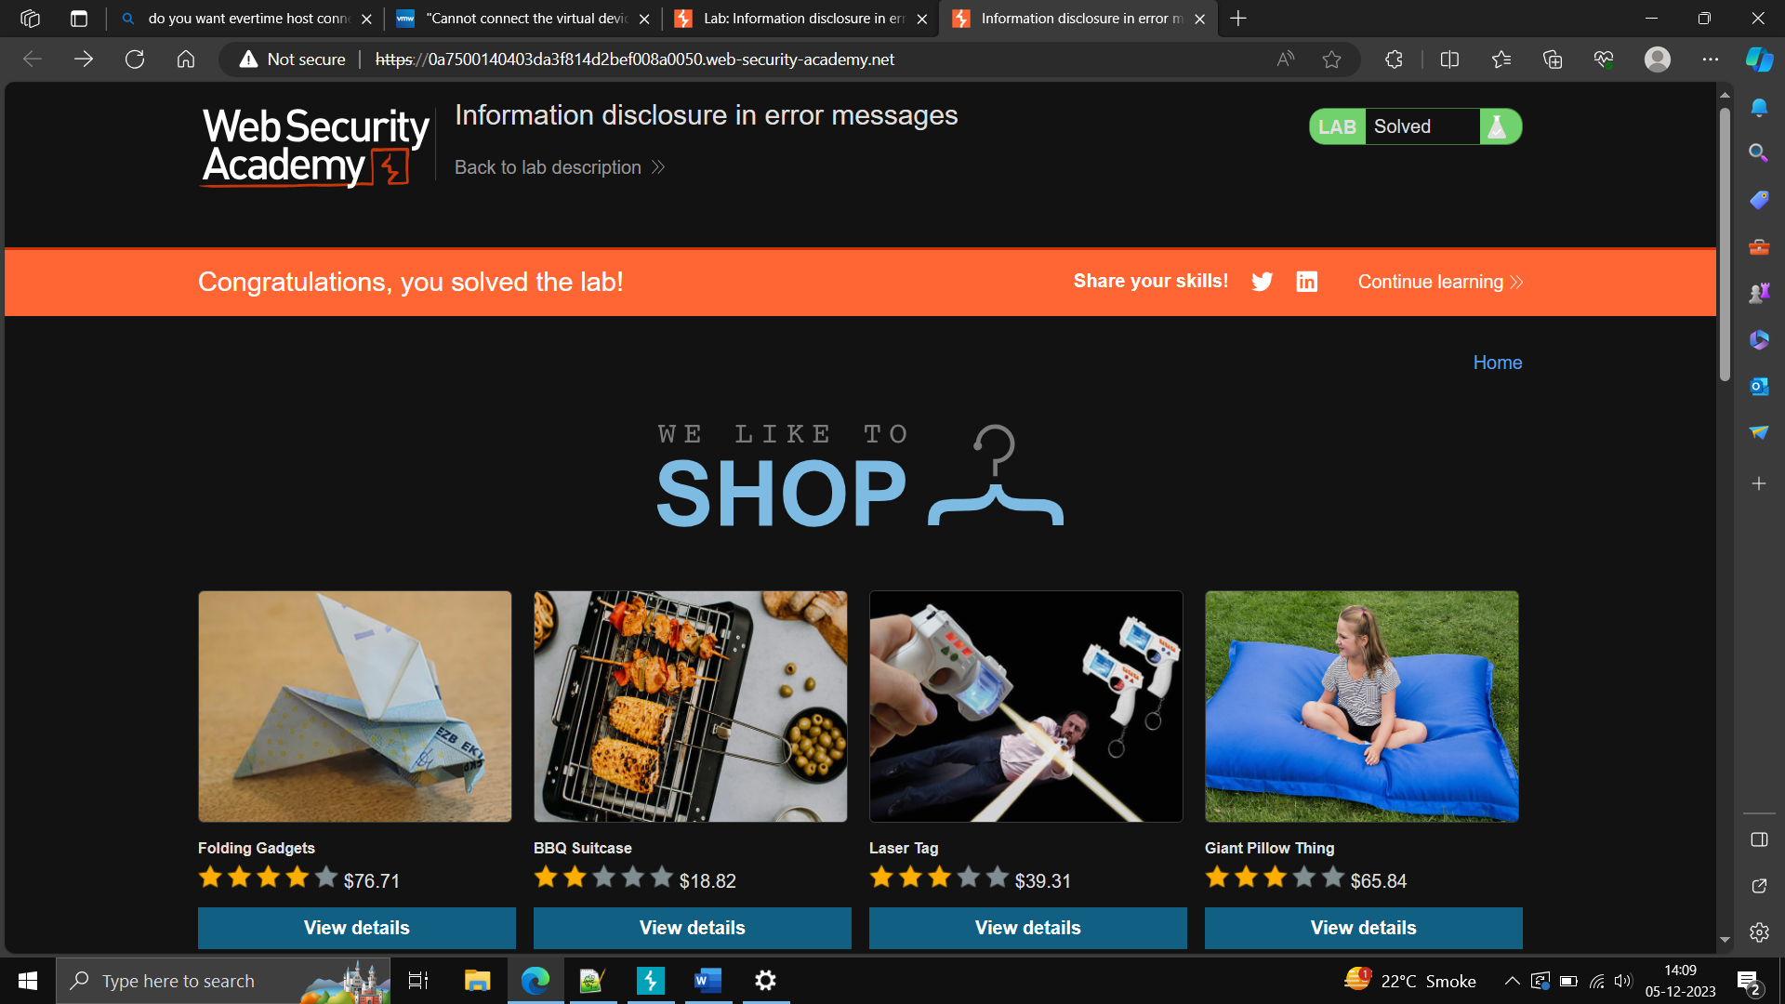

**2.2) -** Information Disclosure on debug page

POC –

Step1) Reload the Website -> intercept On -> right click on the request send to repeater, go on target in burp suite ,click on sitemap-> check the website URL-> click on cgi-bin -> click on phpinfo.php

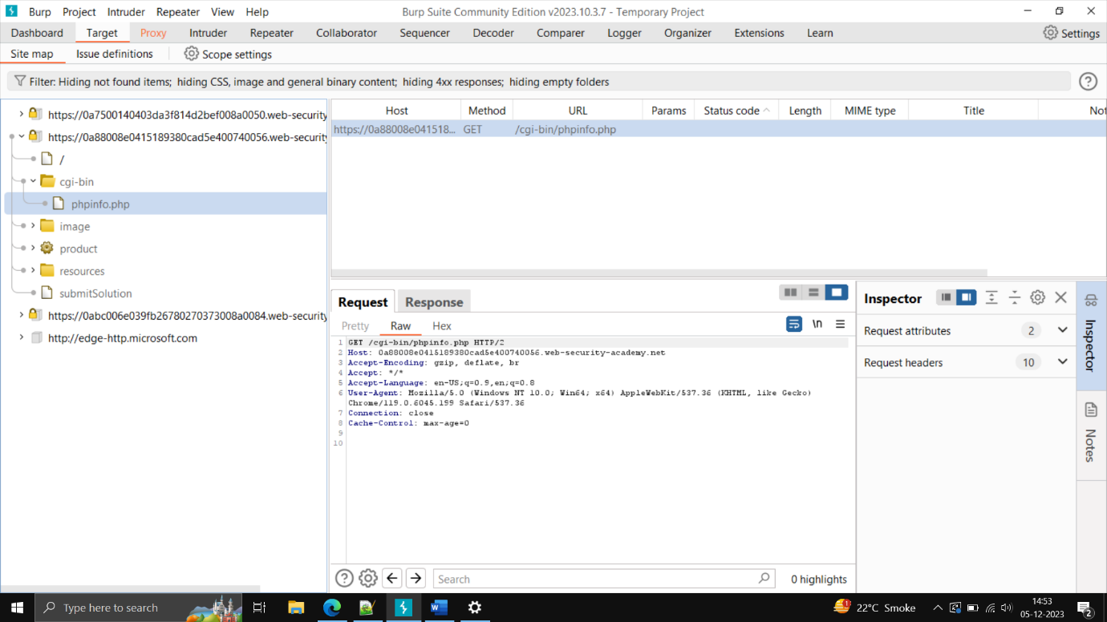

Step2) – check the request and click on send button.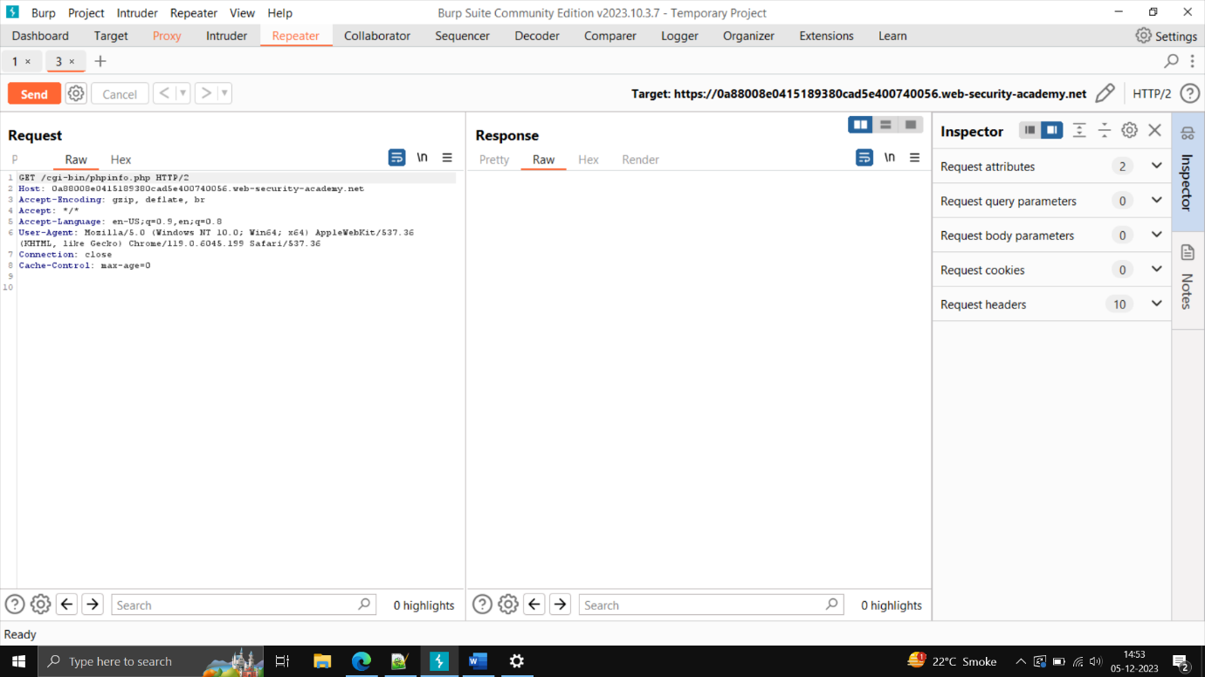

Step3)- in the response go down check the secret key-> copy the secret key, submit in website

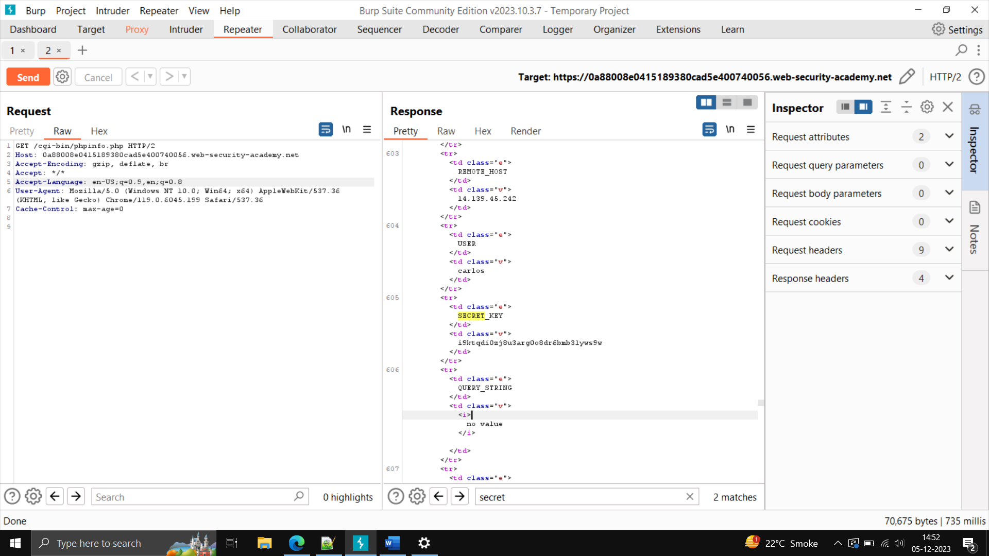

2.3) Lab – Source Code Disclosure via backup file

Step1)- open the site -> on the intercept.

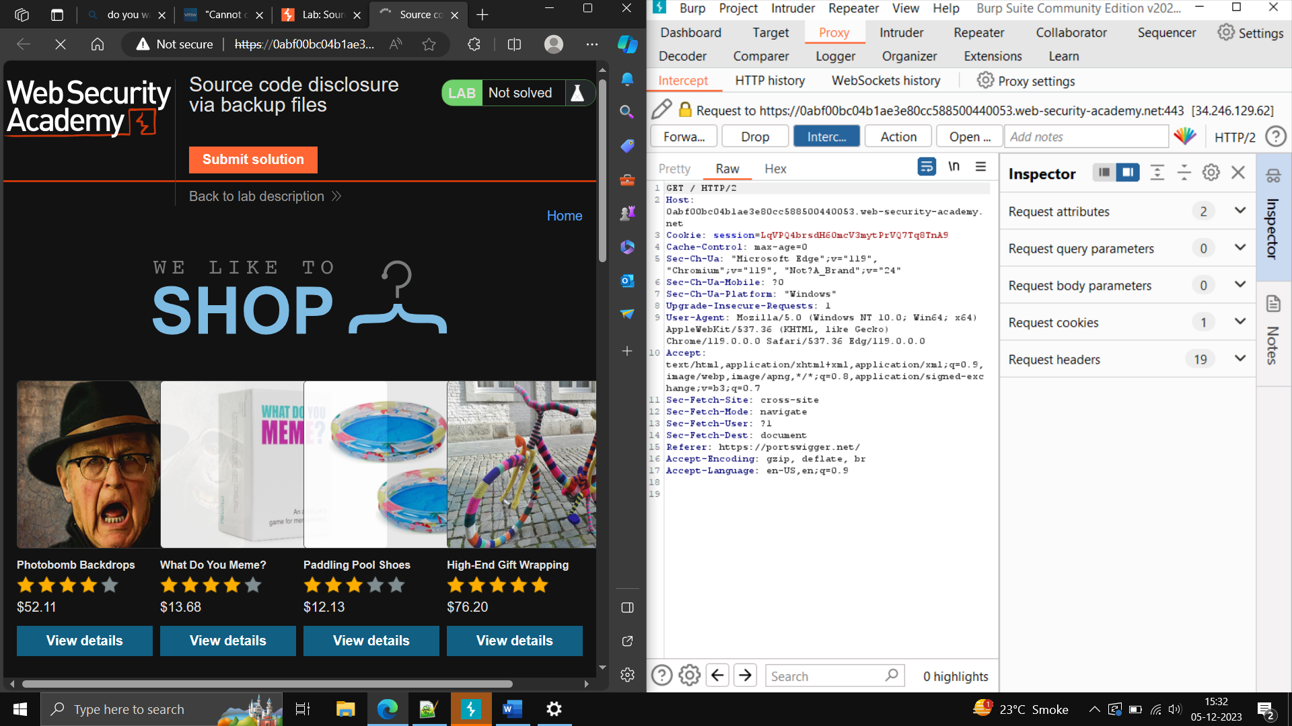

Step2)- off the intercept -> on URL put /robots.txt.

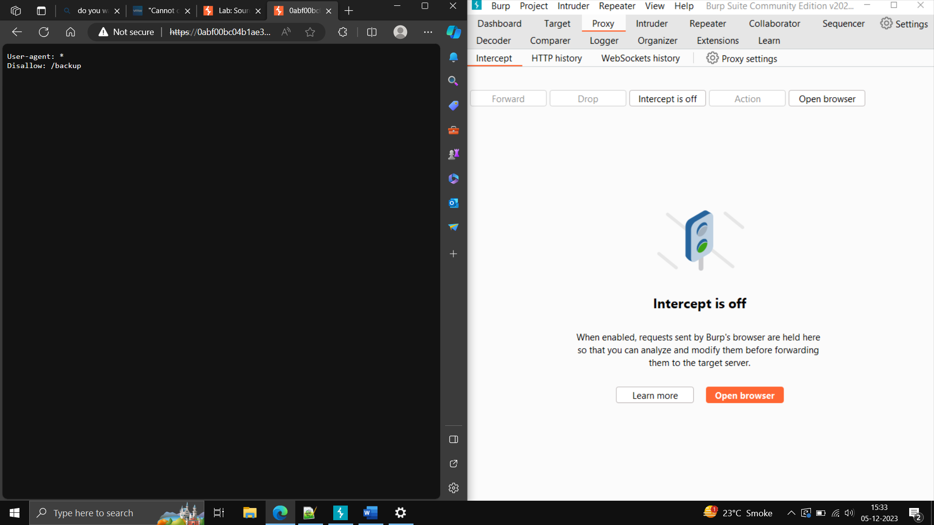

Step3)- you will notice /backup/ -> remove robots.txt file from URL and enter -> on the intercept reload the site

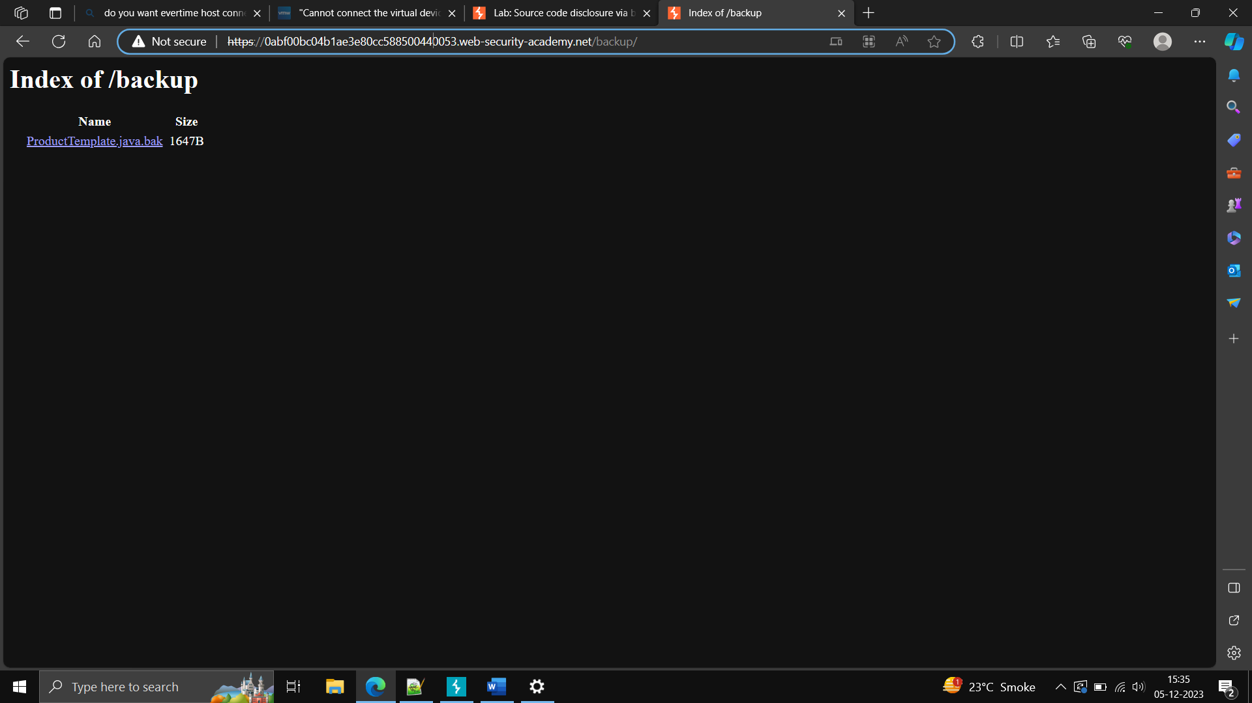

Step4) go on target on burp suite -> sitemap -> you will notice the site, open it-> you will find backup folder

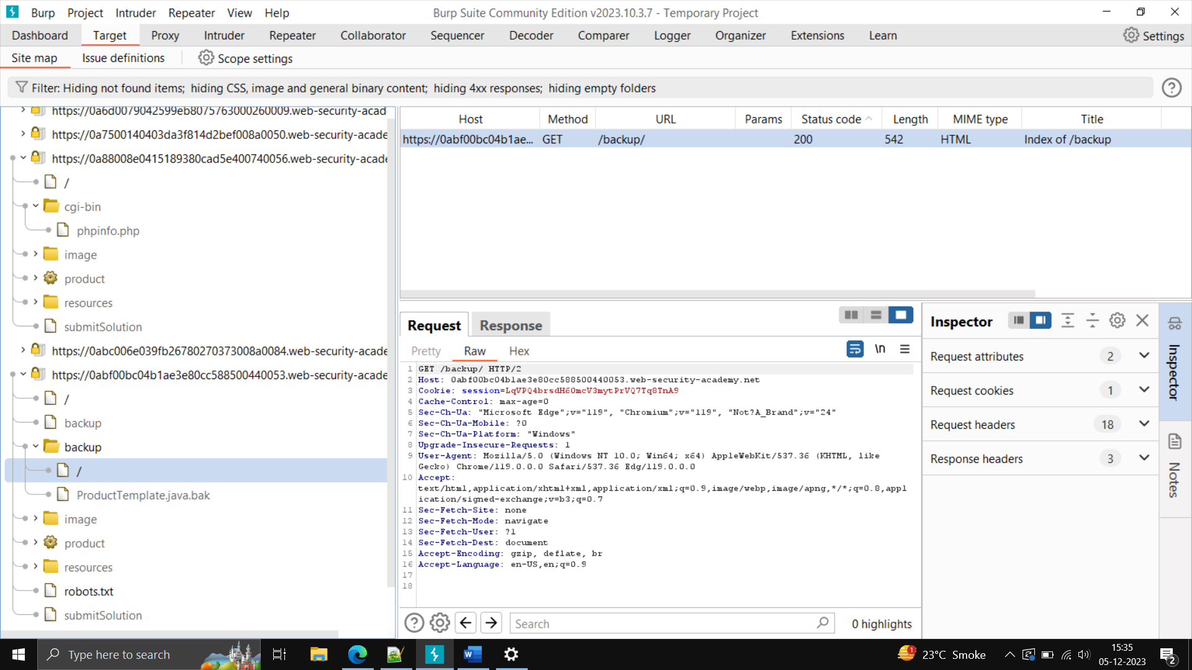

Step5) click on forward slash -> you will notice request in burp suite -> right the request send to repeater

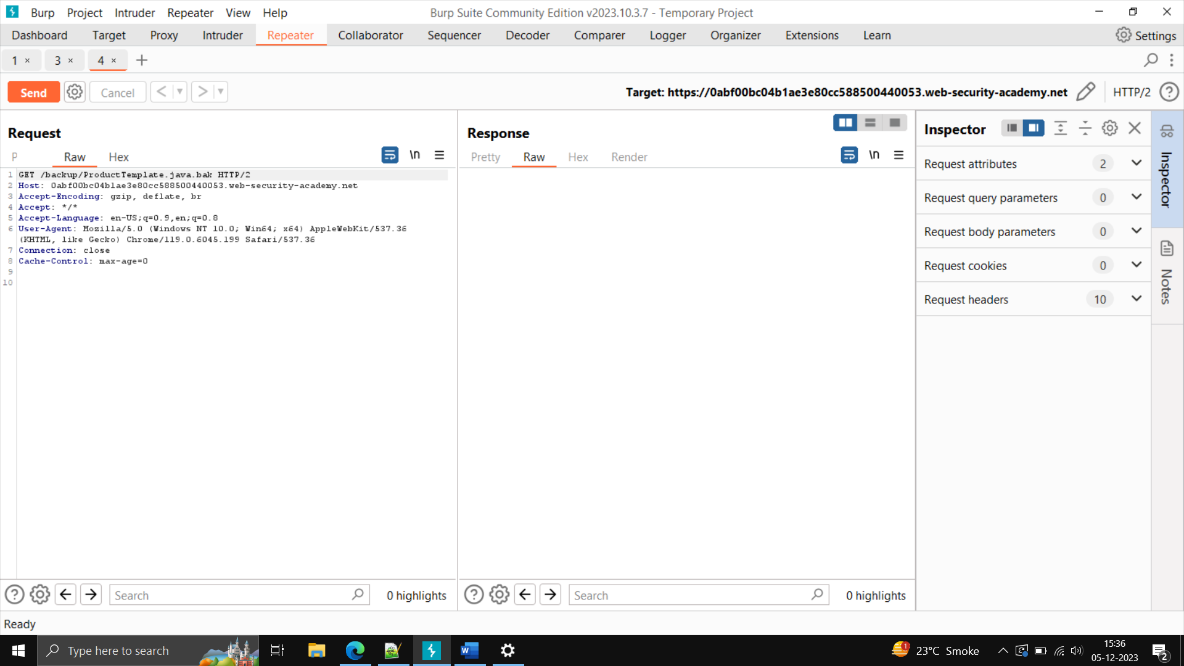

Step6) send the request and get the response in repeater

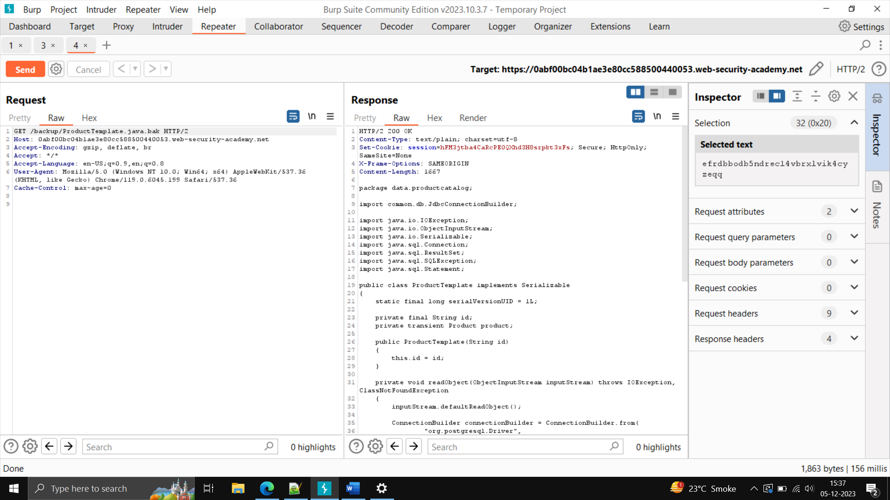

Step7) go down in response -> you will notice “productivetemplate.java.back” ->copy it ->paste in request -> click on send button -> check the response and go down, you will notice database key is revealed.

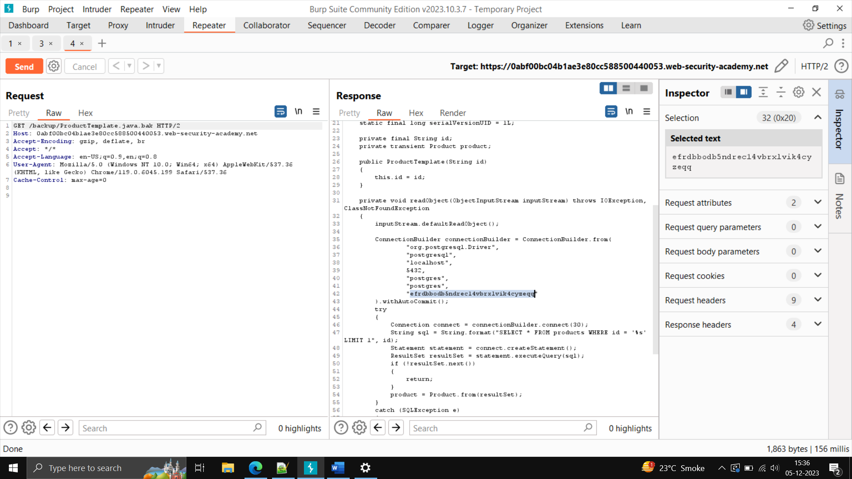

Step8) – copy the database key-> paste in website -> submit Solution -> click on OK.

**3) SQL INJECTION**

Description -

It is a common attack that uses malicious SQL command for backend database manipulation to access information for example -sensitive company data, user lists etc

Impact –

By this injection, unauthorized person can view user list, delete the record, misuse information etc.

References – [SQL Injection (w3schools.com)](https://www.w3schools.com/sql/sql_injection.asp)

Severity: HIGH

POC –

Step1) - open demo.testfire.net

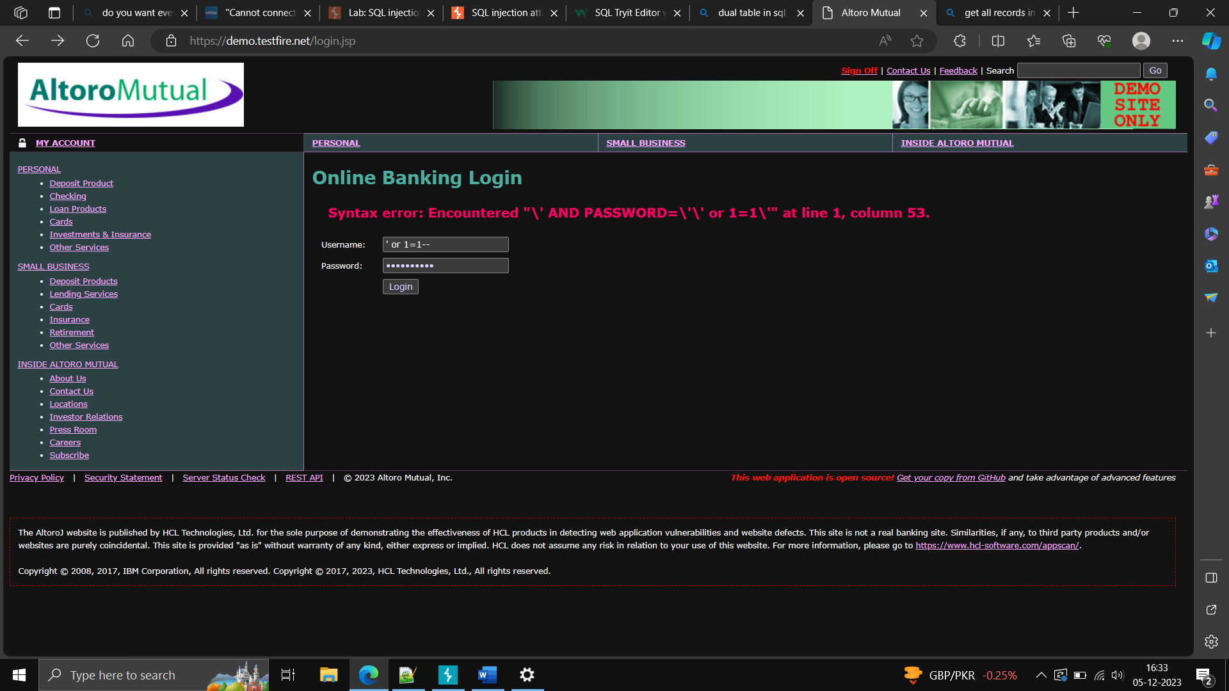

Step2) – click on login -> write the payload -> ‘ or 1=1--+ in username and password, click on login

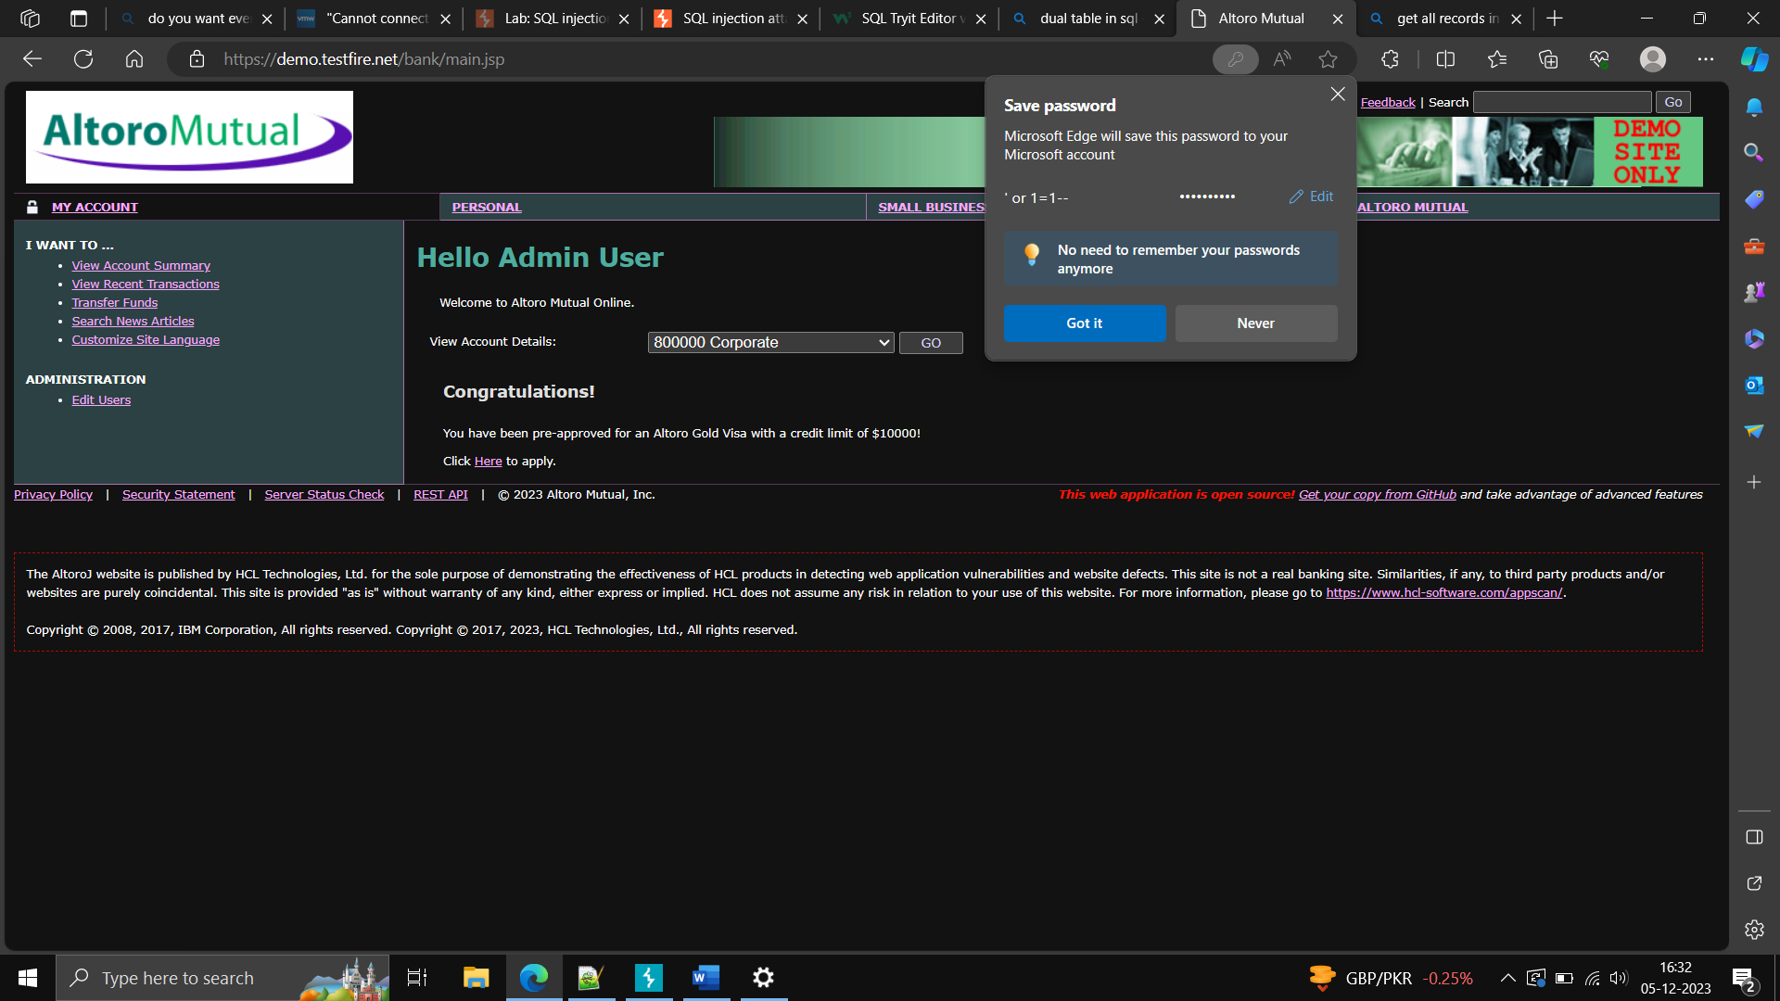

ORACLE **SQL—**

**To create a table, we use**

**Create table student (name varchar (30), id int not null primary key, address varchar, marks int);**

**SQL INJECTION -**

**What is sql injection**

**It is web security vulnerability that allows an attacker to interferes with the queries that an application makes to its databases, this can allow an attacker to view data that are not normally able to retrieve.**

**In some situation an attacker attack to compromise the server, database, any other backend infrastructure.**

**What is the impact of SQL injection –**

**It can result in unauthorize access to sensitive data such as passwords, credit card details, personal user information**

**How to detect sql injection vulnerability –**

1. **Single quote character(‘) and look for errors**
2. **Boolean condition such as OR 1=1 AND OR 1=2 ,for application responses**
3. **Payloads design to trigger time delays when executed within sql query and look for difference in the time taken to respond.**

**Sql injection in different paths of the query – most sql injection vulnerabilities occur where clause of a select query**

**Sql injection vulnerability can occur at any location within the query and with different queries types.**

**Update statement**

**Insert statement**

**Select statement**

**Order by clause**

**How to find an exploit**

**Different types of sql vulnerabilities**

**How to prevent sql injections**

**SQL injection vulnerability- in where clause allowing retrieval of hidden data**

**-------Install havji by disabling firewall and antivirus**

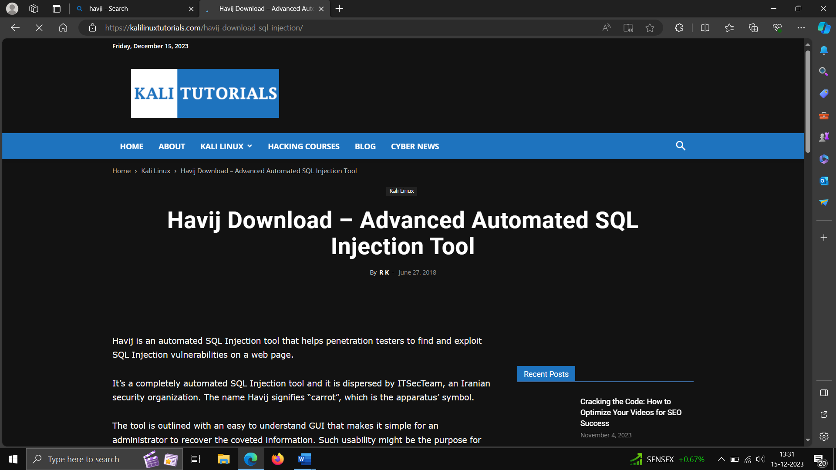

**POC – Step1- open the browser ->access the above lab , go to any product category**

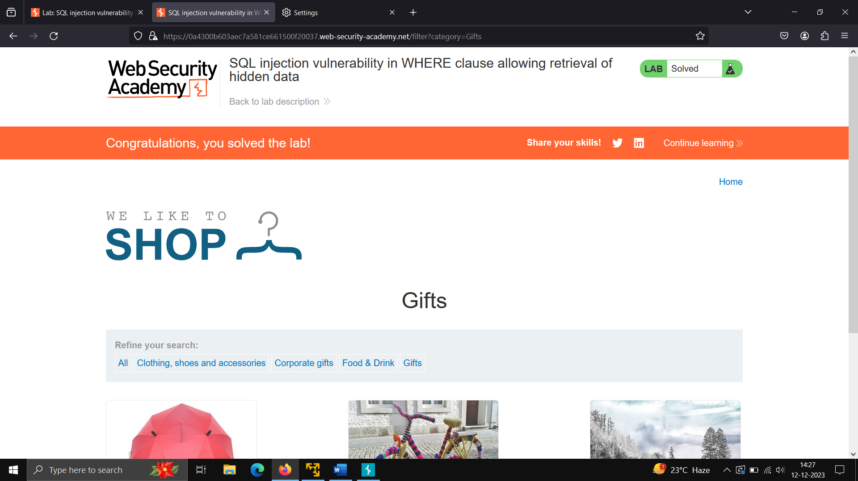

**Step2- now send the request to repeater and manipulate the request**

**As gifts’or1=1—**

**(use the payload the statement will get true(or1=1) and – is used for commenting the line after the payload).**

**Step3 – send the request and http request we got is 200 OK.**

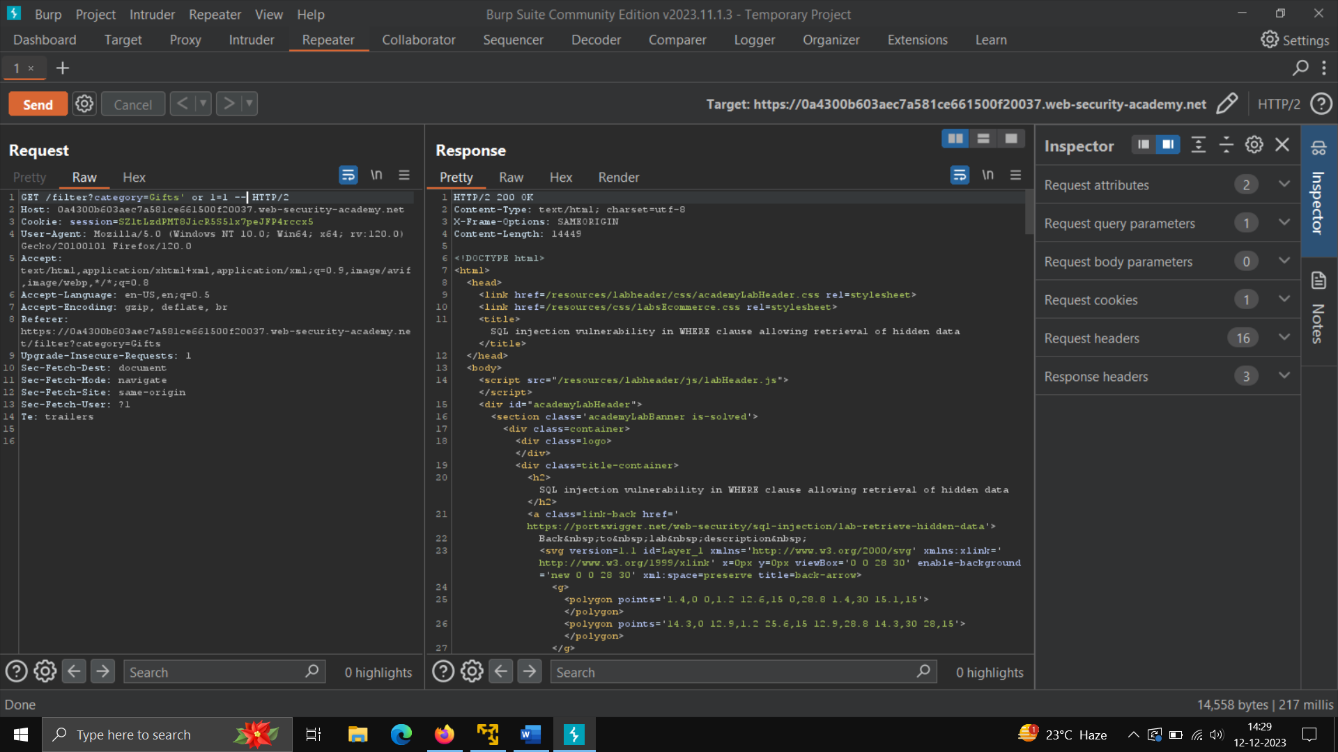

**How to install port swigger CA certificate in browser**

**Step 1-)**

**Open burp Suite click on the proxy settings -> click on regenerate CA certificates.**

**It will be downloaded in our download folder.**

**Step2-) open the browser write** [**http://burp**](http://burp)

**Step3 – download the CA certificate -> in setting -> type view certificates -> in authorities -> import the certificate.**

**2) SQL injection vulnerability allowing login bypass**

**Open the site and login, give the credential administrator and password-12243, put intercept on , click on login, forward the request , inside the request, edit username – administrator’ – and forward the request.**

**POC –**

**Step 1 – open the broswer, click on acces the lab, on the Intercept.**

**Login through above credential.**

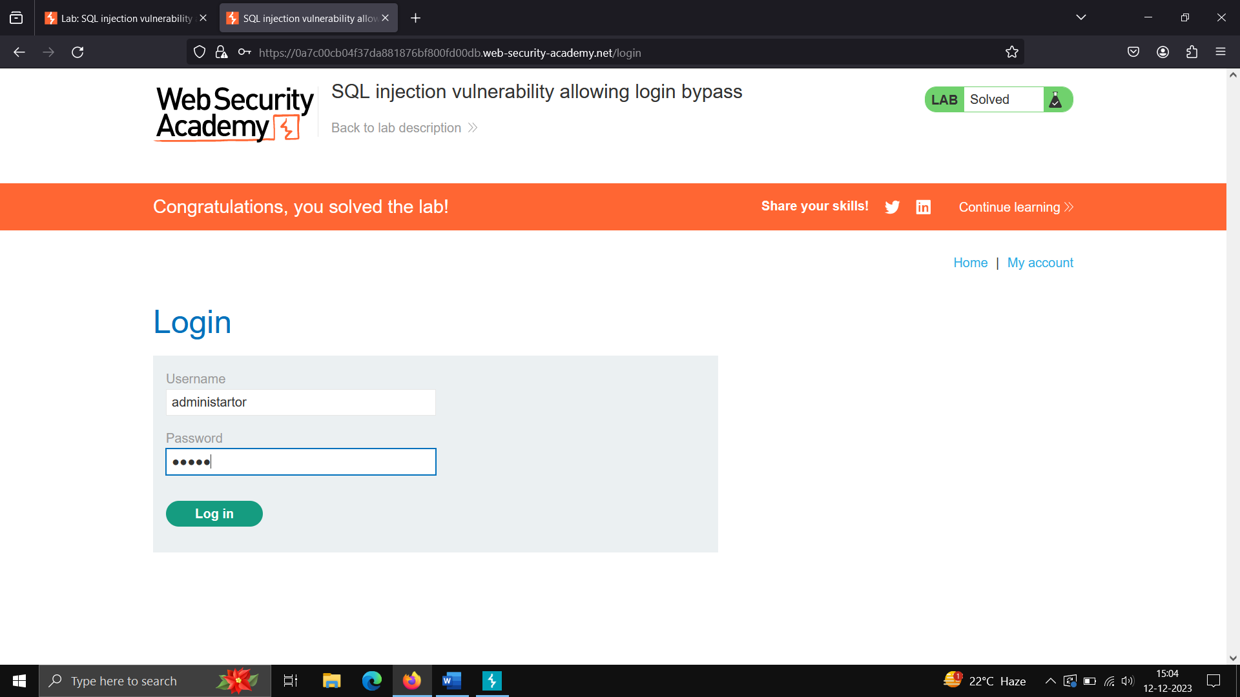

**Step2 – check the request in proxy tab and manipulate the administrator to administrator’ – and forward the request.**

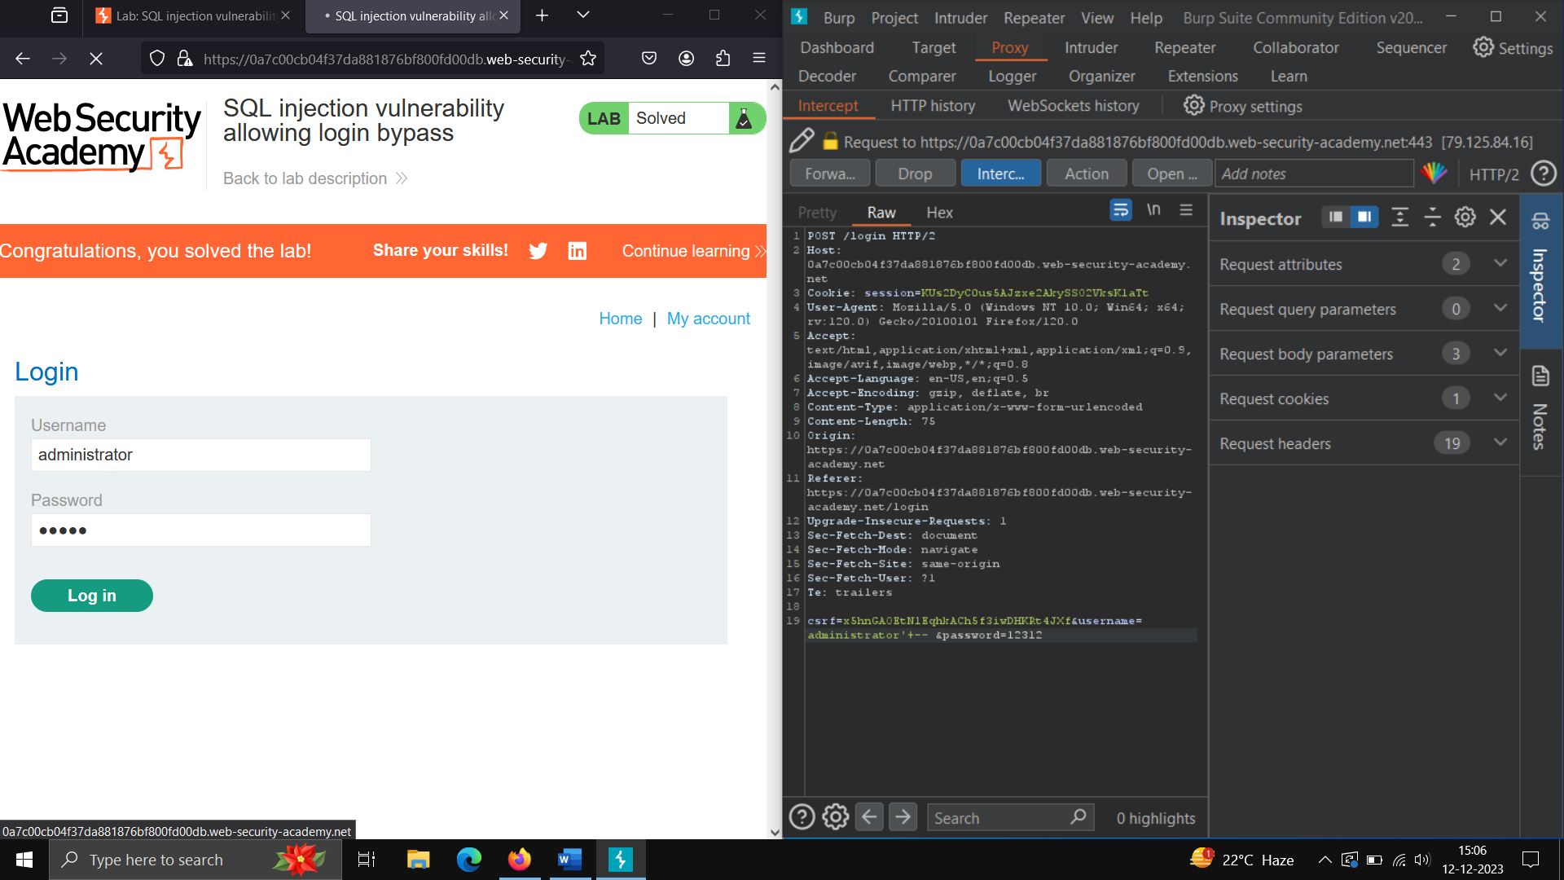

**Now we have login to administrator**

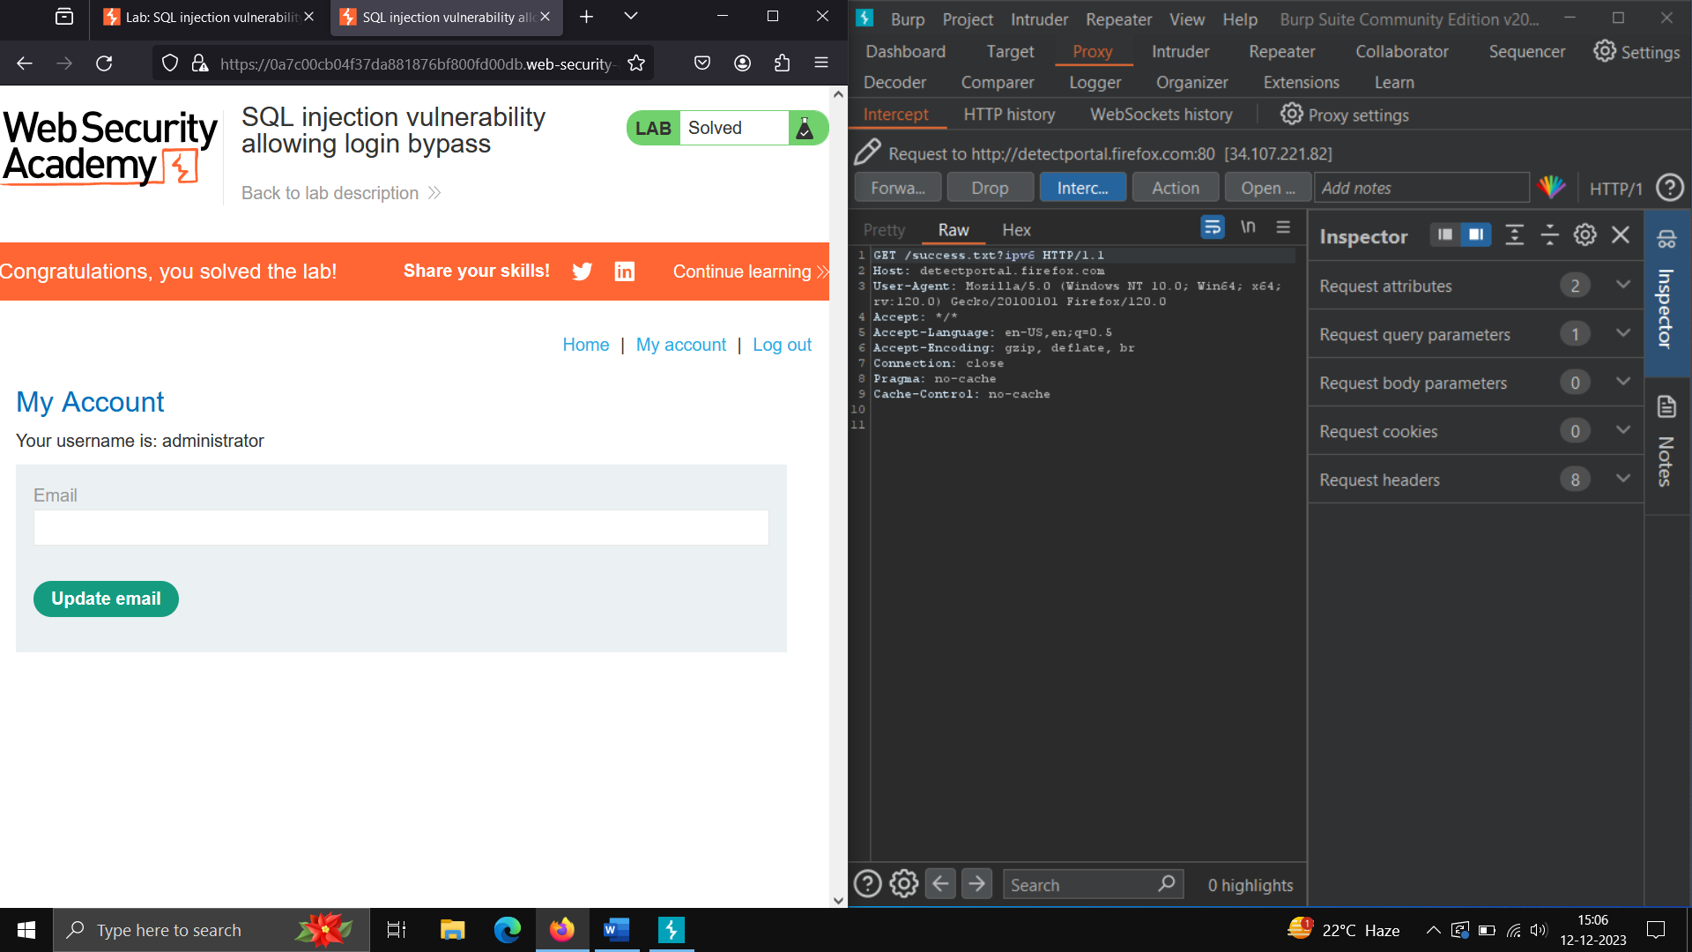

**Union operator is used to combine the data from the result of two or more select command into distinct result. This operator removes any duplicate present in the result**

|  |  |
| --- | --- |
| **1** | **3** |
| **2** | **4** |
| **3** | **5** |

|  |
| --- |
| **1** |
| **2** |
| **3** |
| **4** |
| **5** |

**Result from union - >**

**Syntax for using sql union operator**

**Select column1, column2, column_n**

**From table_1**

**UNION**

**Select column1, column2, column_n from table 2.**

**………………………………………………………………………………………………………………….**

**SQL injection attack ,quering the database type and version on Oracle->**

**POC – Step1 –**

**Open the lab and click on any category - >**

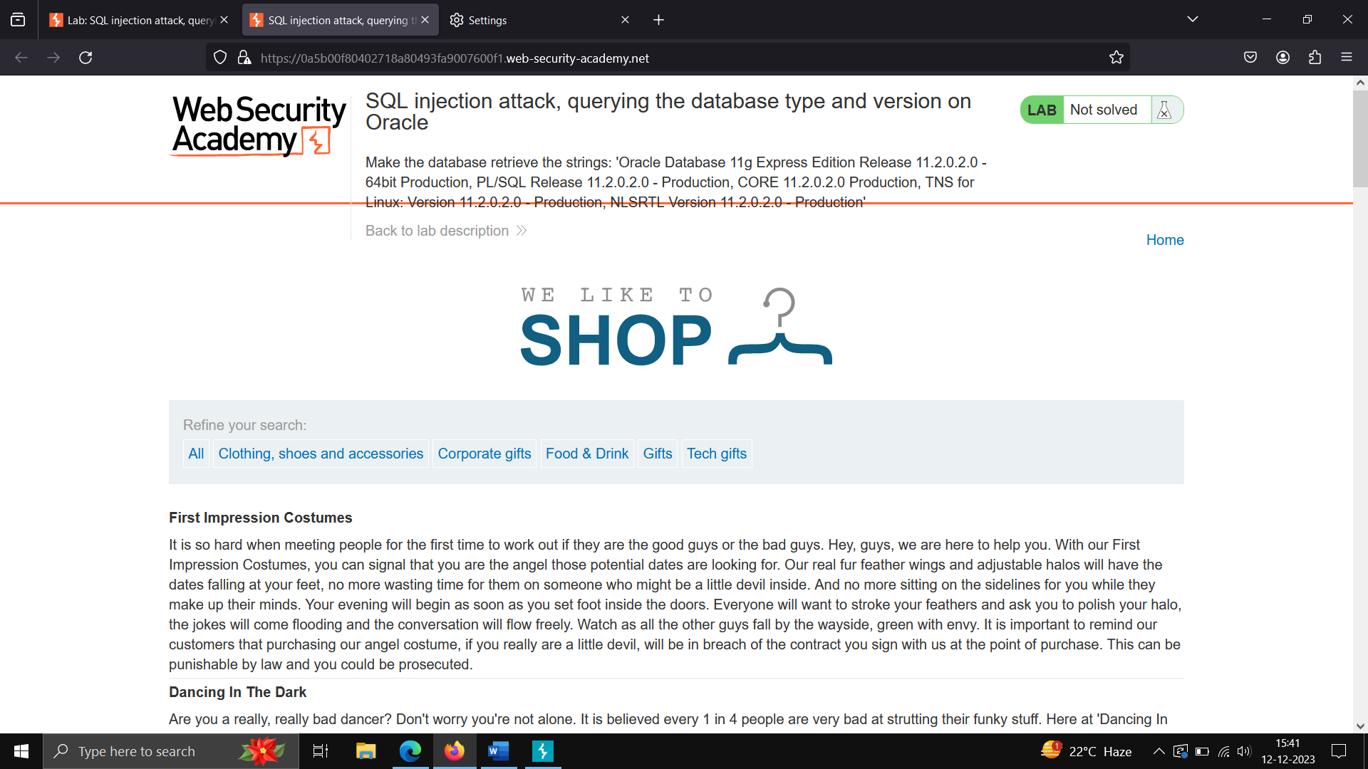

**Step2)Send the request to repeater and identity how many column are there to perform union operation**

**This query let us know that an sql injection is possible –**

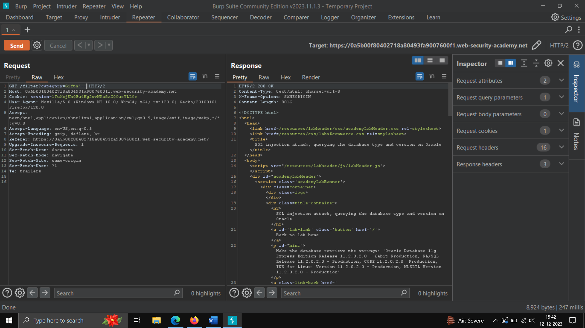

**Now use union with NULL as column – we get to now that we have 2 columns- dual is the default table in oracle for printing any thing in console.**

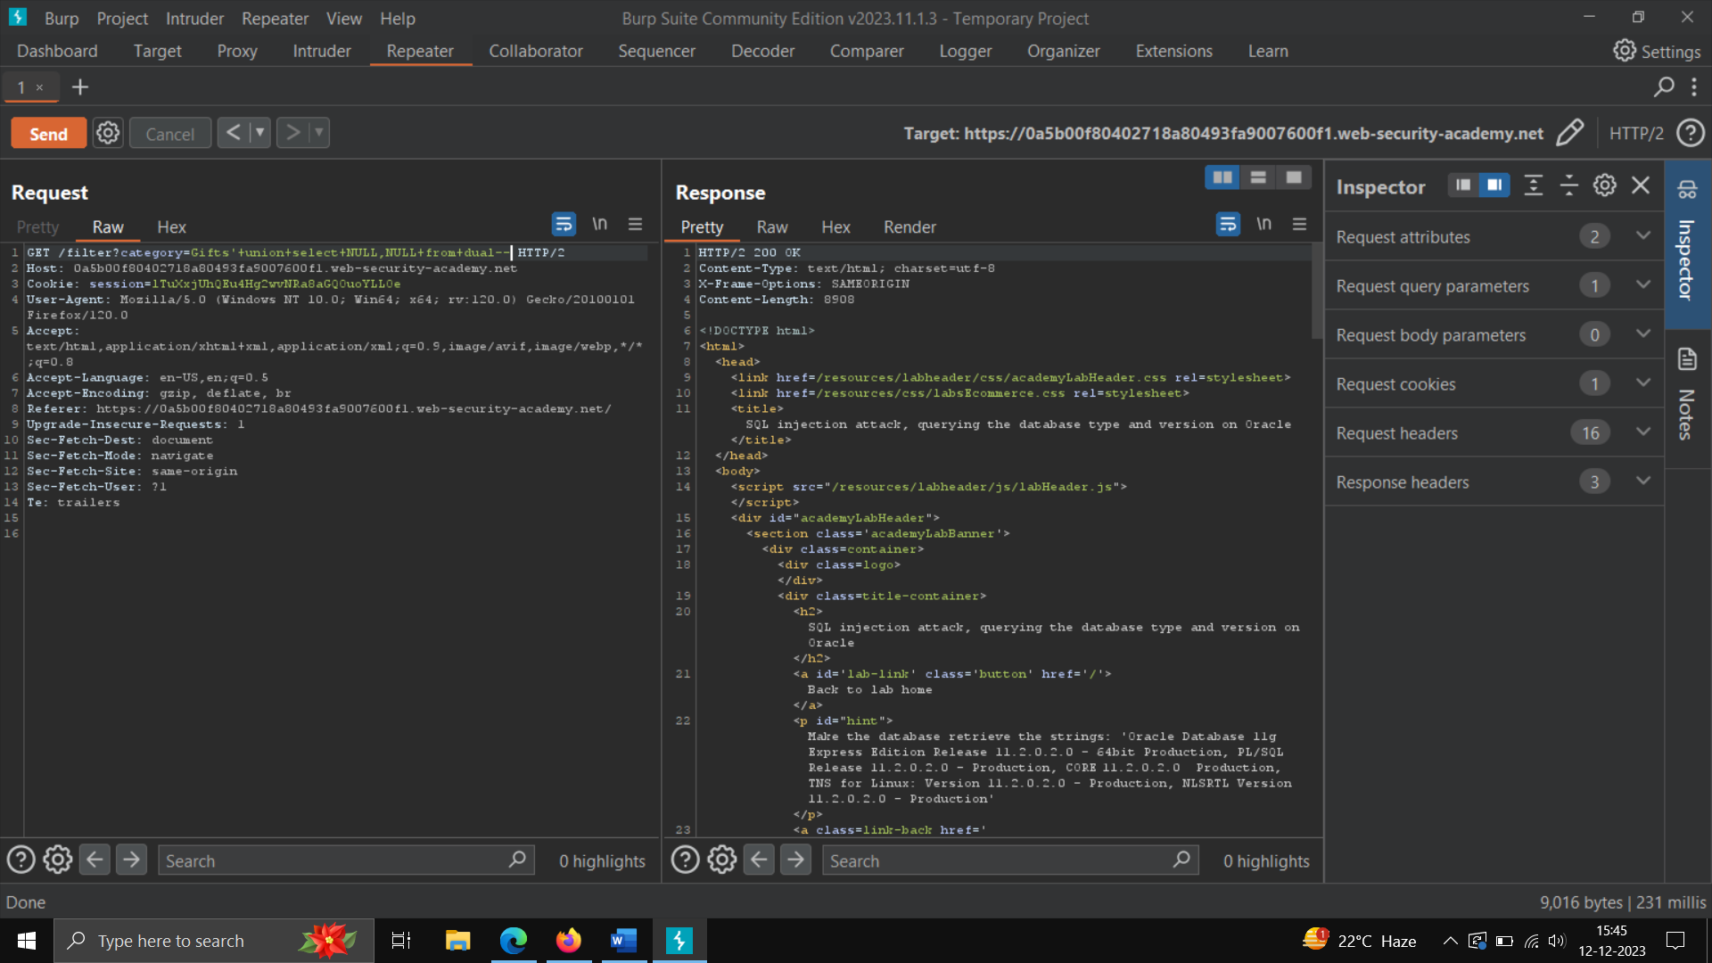

**We get the version using below command –**

**Gifts'+union+select+BANNER,NULL+from+v$version--**

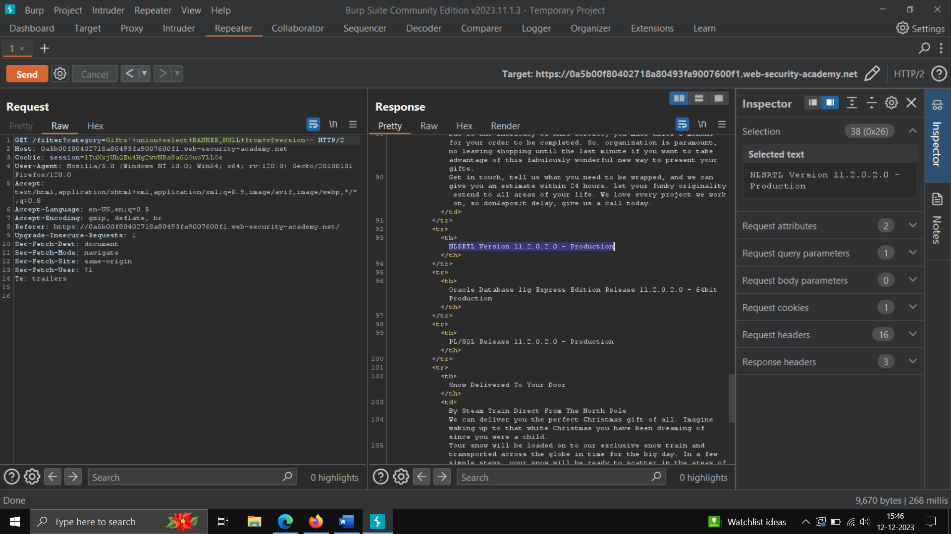

**Lab: SQL injection attack, quering the database type and version on MYSQL and Microsoft**

**We will check column similar as above**

**Now we will intercept the request and check the response using command –**

**Pets'+union+select+NULL,@@version--**

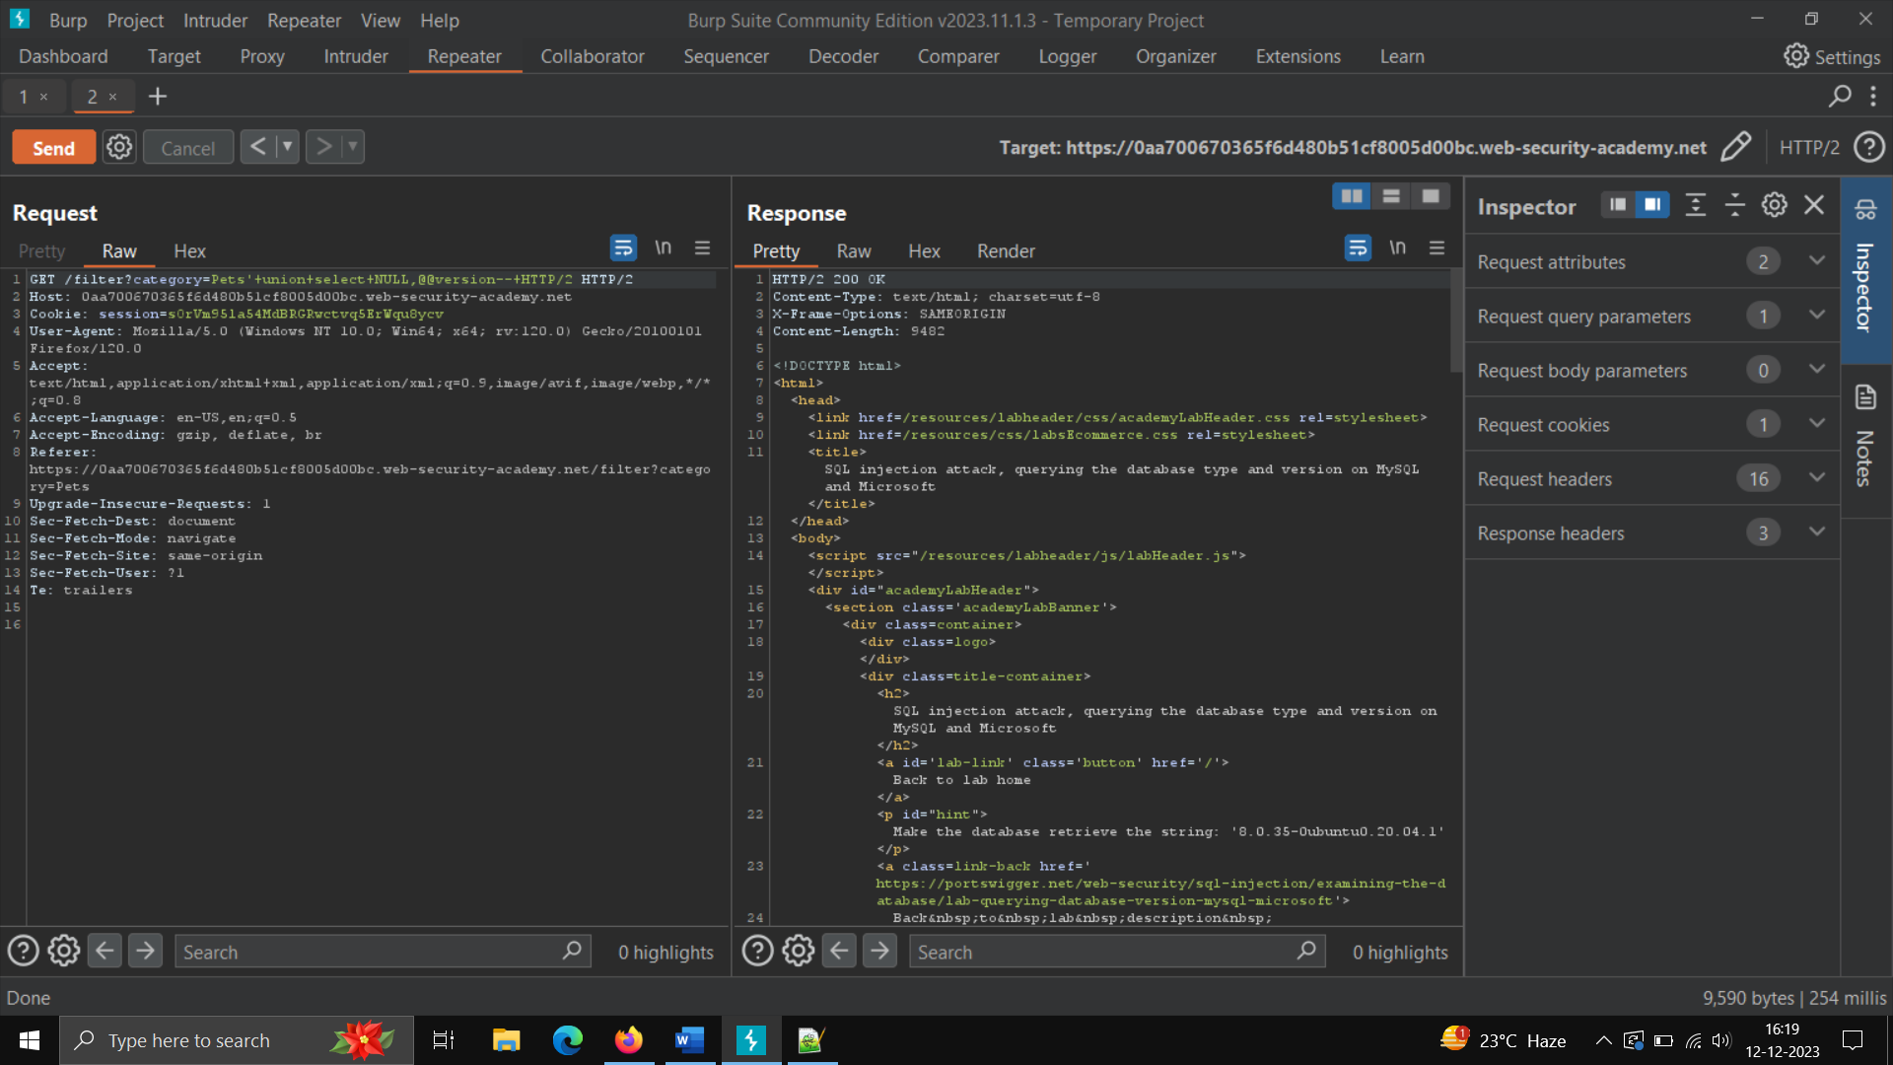

**3.2 XML INJECTION**

Description –

It is an injection attack technique used to manipulate or compromise logic of an application

Impact-

Can Intercept with critical information of the request, for example -payments

Reference –

[What is XXE (XML external entity) injection? Tutorial & Examples | Web Security Academy (portswigger.net)](https://portswigger.net/web-security/xxe)

Severity – HIGH

POC-

Step1)- open website ->click on any option ->intercept on

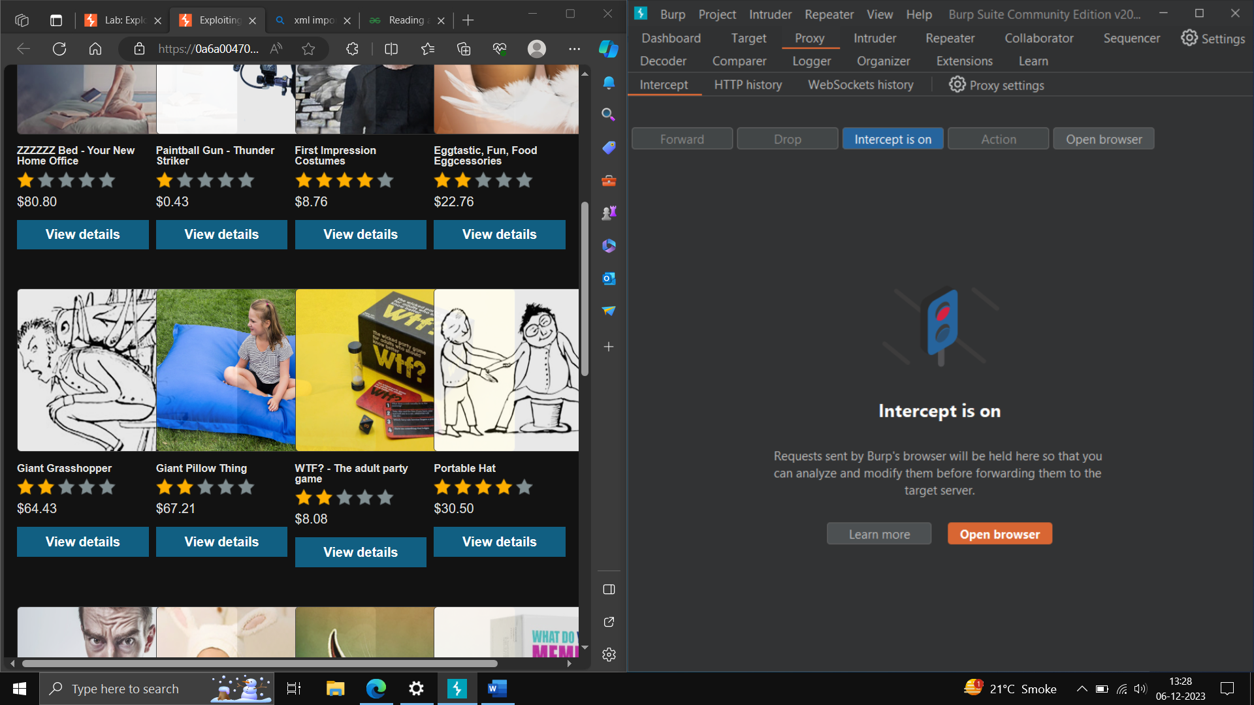

Step2)- tick any stock -> click on “checkstock “

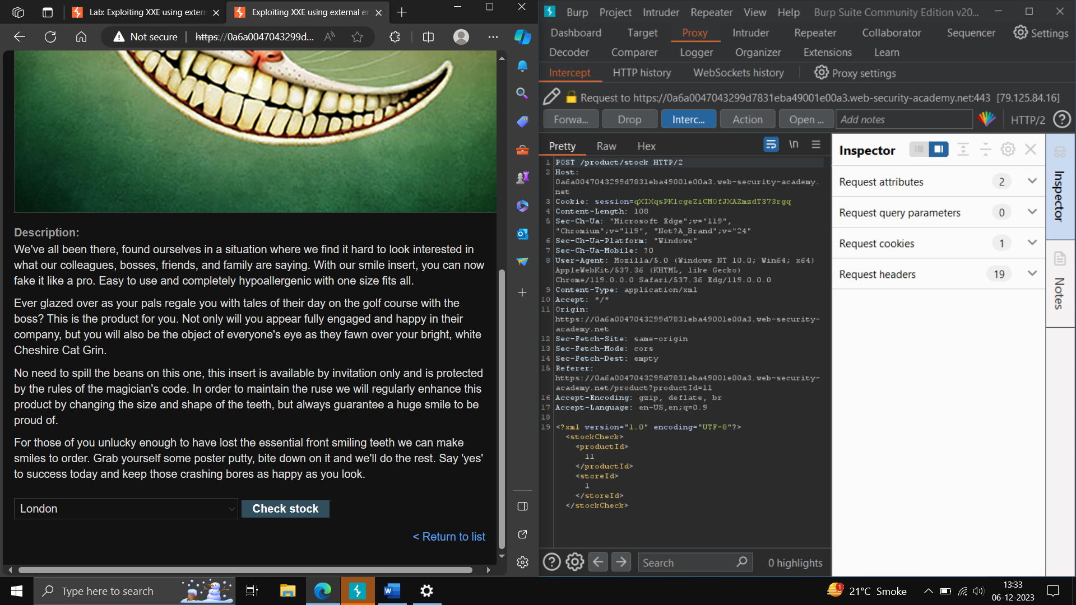

Step3: you will notice xml document in burp suite

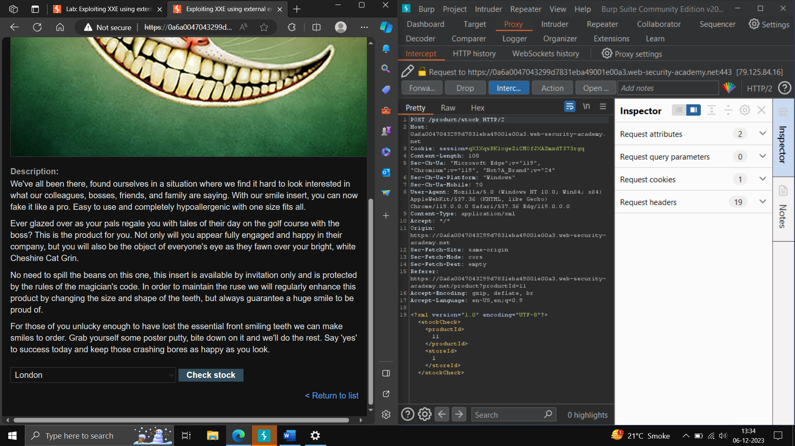

Step4: modify the xml document: -

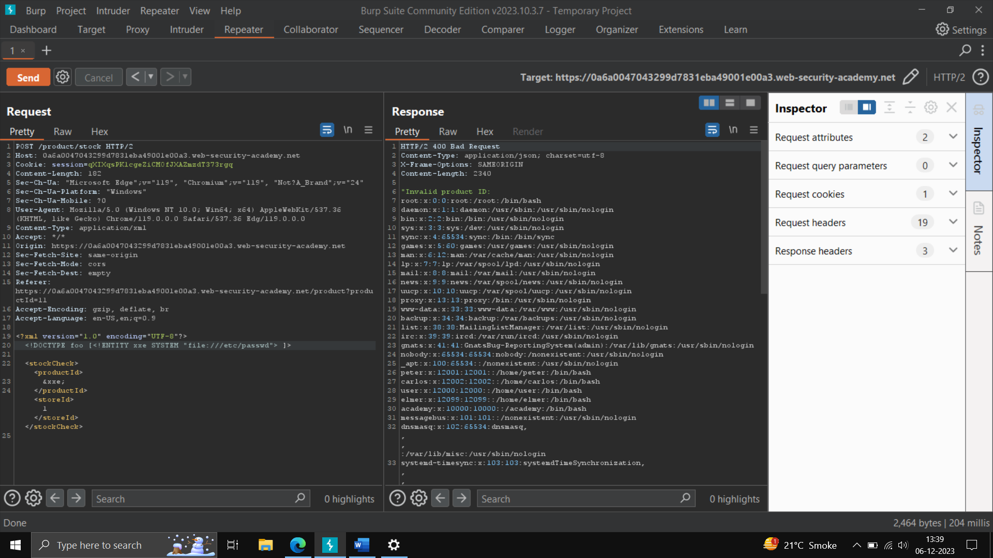

<!DOCTYPE foo [<!ENTITY xxe SYSTEM “file:///etc/passwd”> ]>

Updated xml -

<?xml version="1.0" encoding="UTF-8"?>

<!DOCTYPE foo [<!ENTITY xxe SYSTEM “file:///etc/passwd”> ]>

<stockCheck><productId>

&xxe;

</productId><storeId>1</storeId></stockCheck>

**ZAP PROXY – how to install CA Certificate - >**

Step1) – open zap Proxy, go on tools -> options -> dynamic SSL certificate -> go to new screen -> generate -> Save- > save in desired location -> click on ok

Step2) – go on any browser like Firefox -> settings -> search for view certificates -> click on view certificate, go on authorities, click on import (save file_ -> tick the popup, click ok

Step3) – Now you can open any website in Firefox, set the proxy -> click ok and the setup is ready to perform the task.

Target Website -demo.testfire.net.

Attacks Found ->

**Absence of Anti-CSRF TOKEN**

Description ->

The absence of Anti-CSRF tokens may lead to a Cross-Site Request Forgery attack that can result in executing a specific application action as another logged in user, e.g. steal their account by changing their email and password or silently adding a new admin user account when executed from the administrator account.

Impact ->

The attacker may copy one of your web application forms, e.g. email/password change form.

References –

[Absence of Anti-CSRF Tokens | ScanRepeat](https://www.scanrepeat.com/web-security-knowledge-base/absence-of-anti-csrf-tokens)

POC

Step1 -Step Proxy in Firefox Browser and in browser settings.

Step2 – now click on automatic attack -> click on attack.

Request –

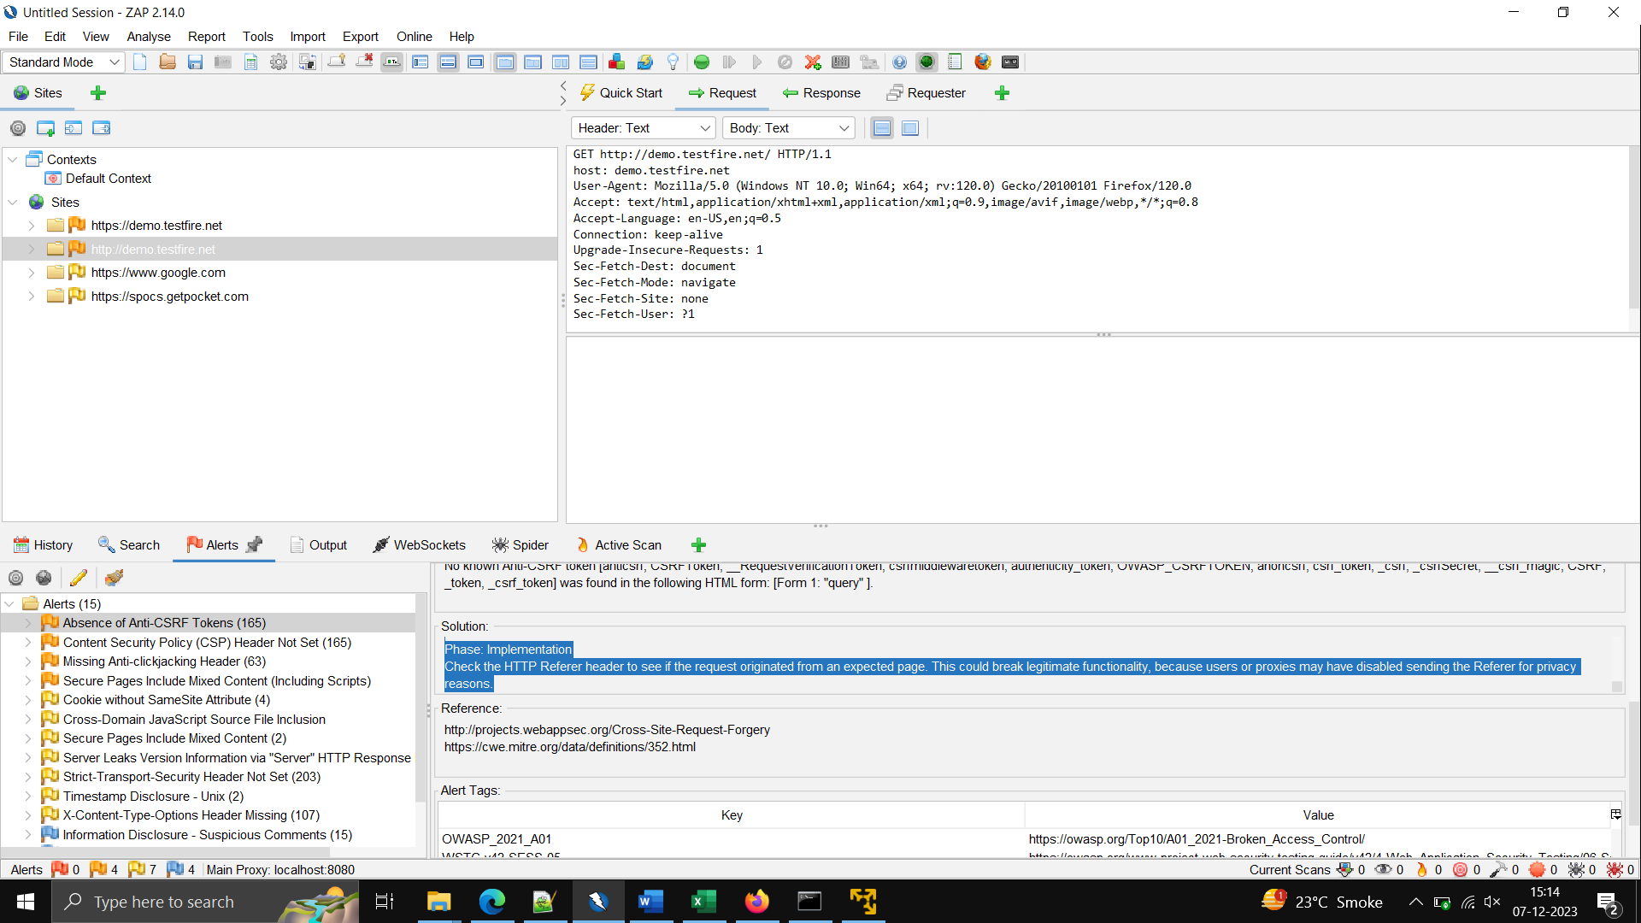

Response –

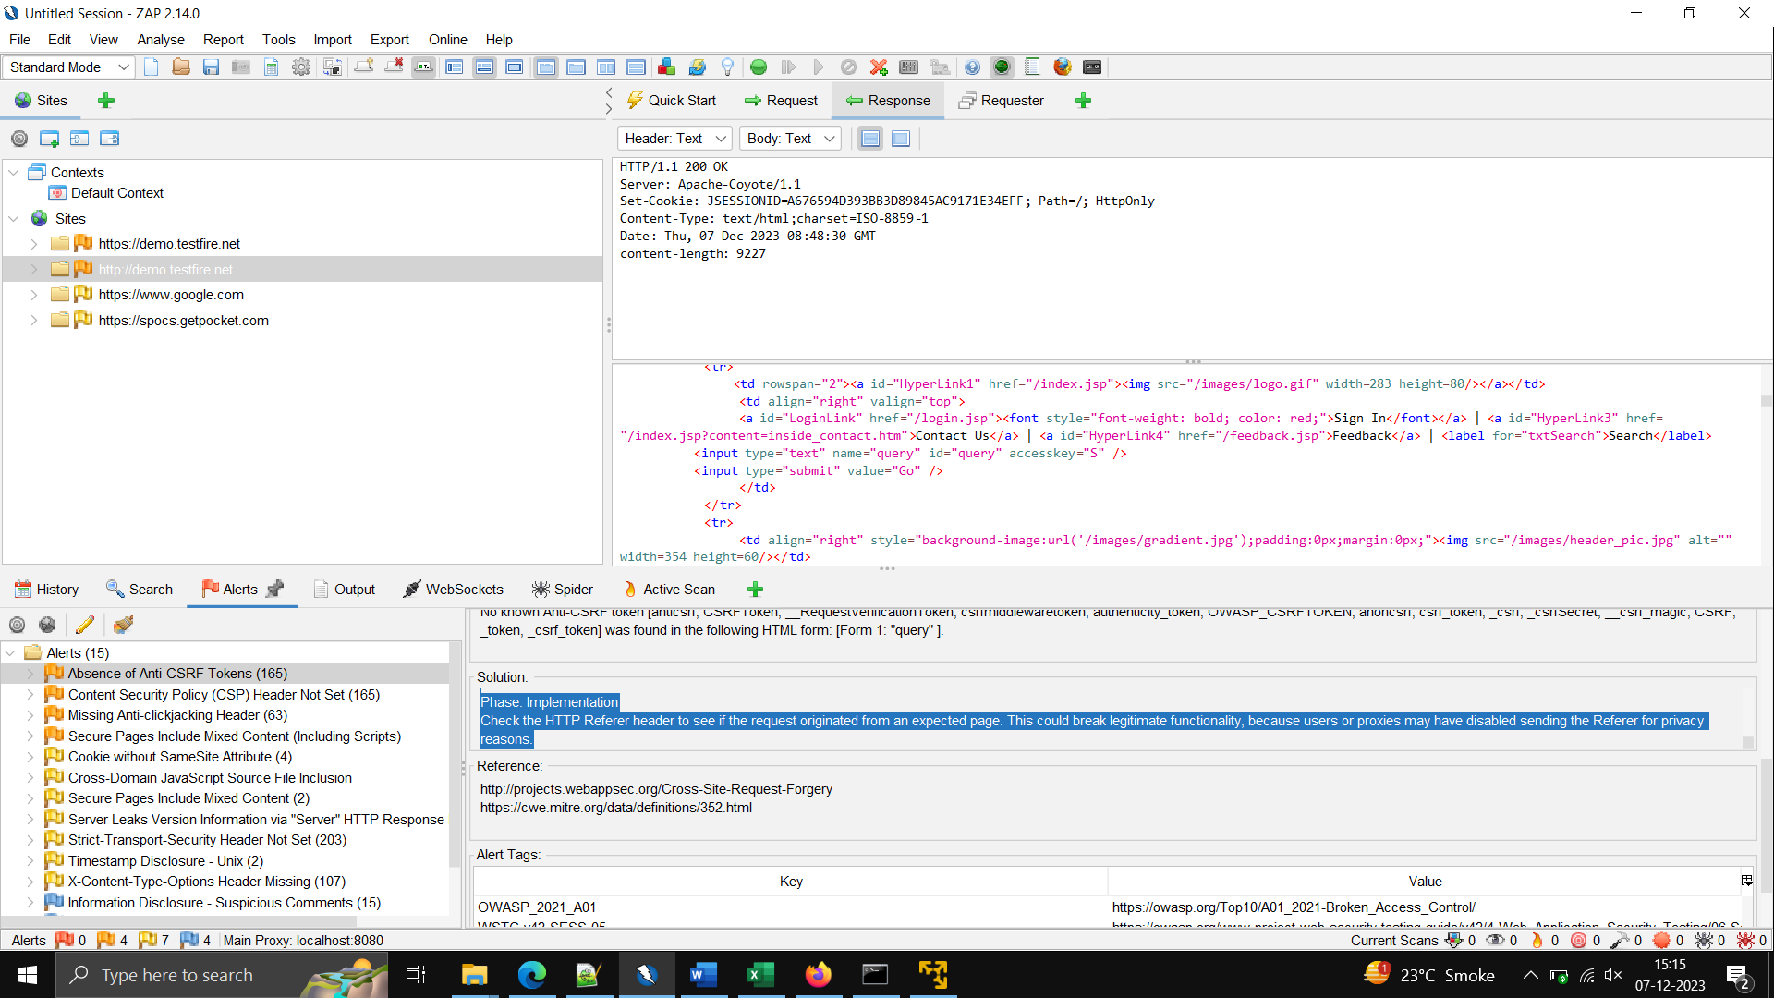

2) – **Missing Anti-clickjacking Header**

Description-

The response does not include either Content-Security-Policy with 'frame-ancestors' directive or X-Frame-Options to protect against 'Clickjacking' attacks.

Impact – The user is redirected to a page with information about the free gift (not knowing what happened in the background).

References –

[What is Clickjacking | Attack Example | X-Frame-Options Pros & Cons | Imperva](https://www.imperva.com/learn/application-security/clickjacking/)

POC – same as above

Request –

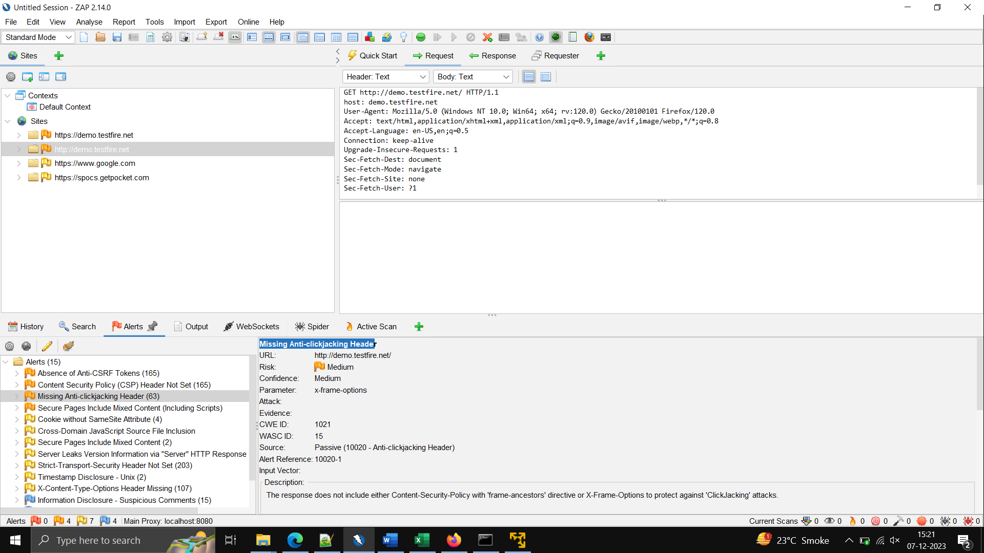

Response-

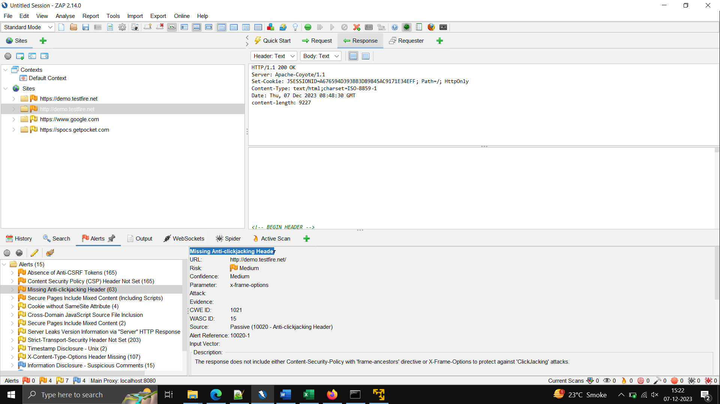

………………………………………………………………………………………………

**OS COMMAND INJECTION**

Description –

This injection mainly uses by attacker to control the operating system by injecting several commands into vulnerable applications.it is used to steal data, crash system and corrupt databases.

Impact-

This vulnerability occurs when input is not properly sanitized, when application passes unsecure data to the system such as cookies, form data, http headers, etc.

Severity- HIGH, MEDIUM

POC-

Step1 – open the website-> click on any option-> scroll the website-> on the intercept, click on the check stock -> go on burp suite, check the request->send the request in repeater -> in repeater, in request->check the store id by-> | whoami-> send the request.

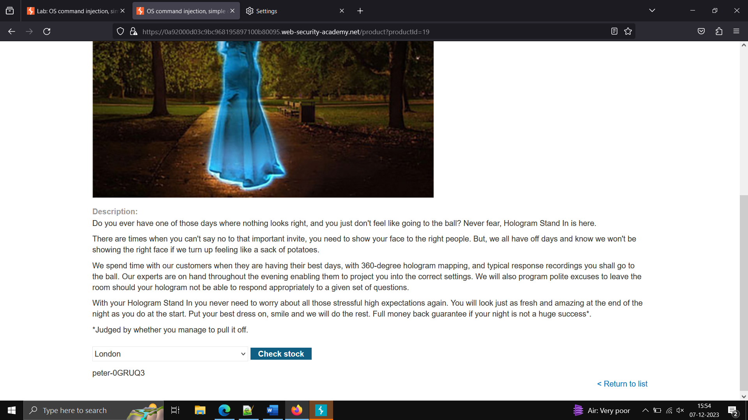

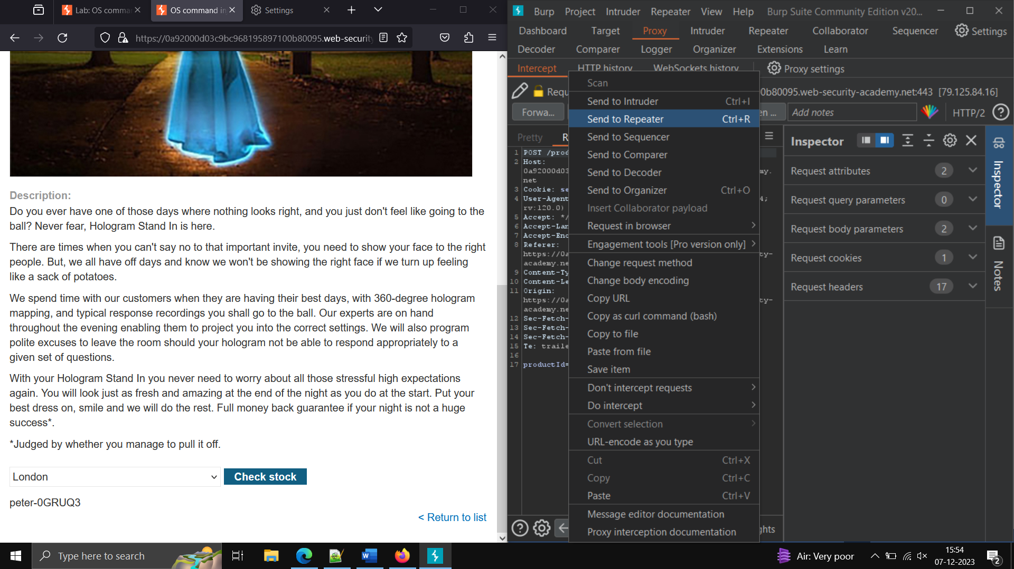

The user is show as below -

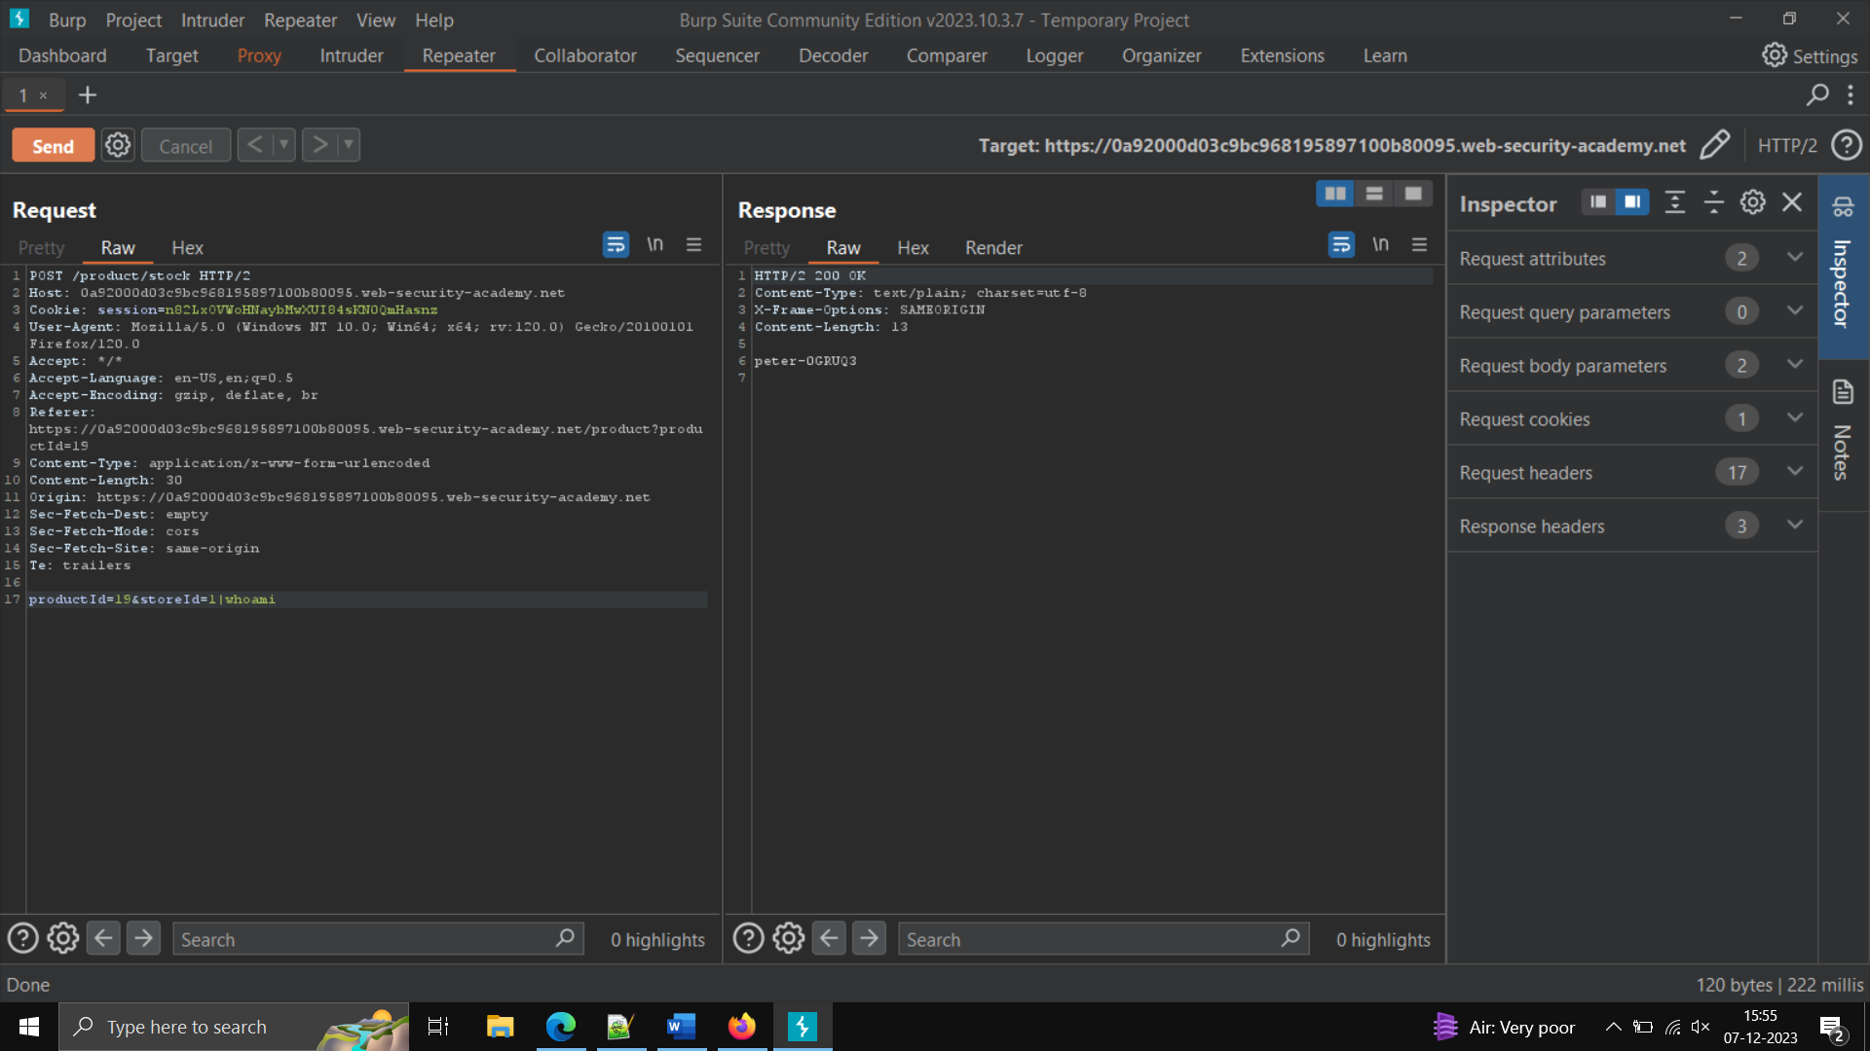

Same vulnerability with time delay

POC -step1)

Open the website -> click on submit feedback -> fill the form-> click ok->you will notice thankyou message appears quickly.

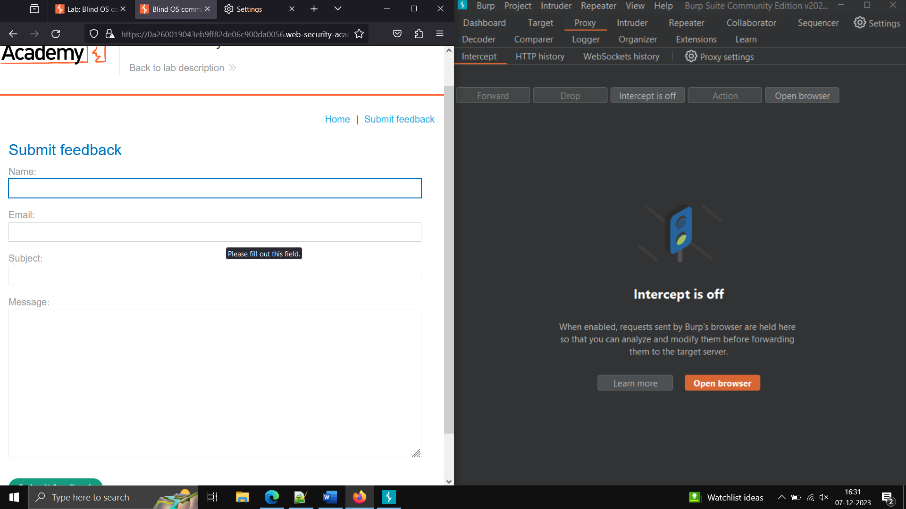

Step2) now fill the form, click on Intercept -> click on submit feedback button -> you will analyse the request in burp suite ->send to repeater ,inside repeater edit the email id by writing your email id then

- > email=x||ping+-c+10+127.0.0.1||

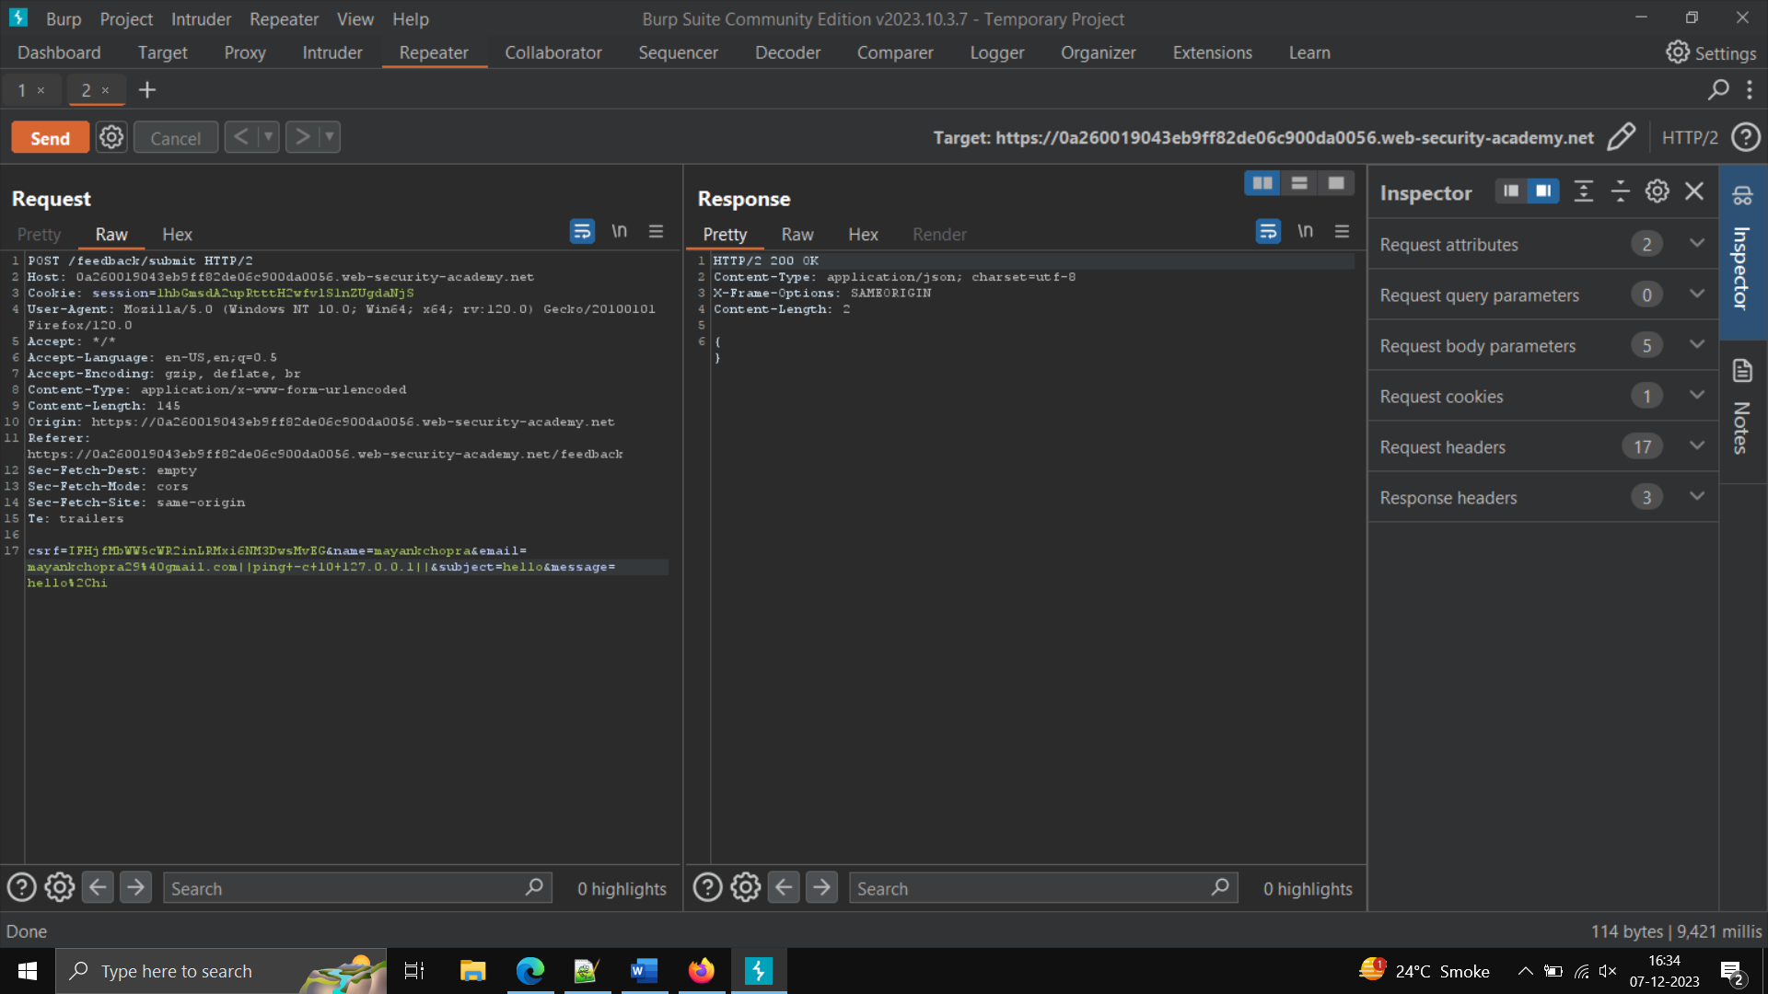

Perform a lab of information disclosure to show error messages and backup files -done

10) **Server-Side Request Forgery**

Description -

It is a vulnerability that allow an attacker to cause the server-side application to make requests. They may be able to force the server to connect the external systems

Impact –

It could leak sensitive data such as authentication credentials.

LAB1) – Basic SSRF against local server.

Step1 – open the website -> click on check stocks -> after putting intercept on.

Step2 – Analyse the request in stock API

Step3 – Edit stock API by writing <http://localhost/admin> -> send the request , you will notice admin page appears.

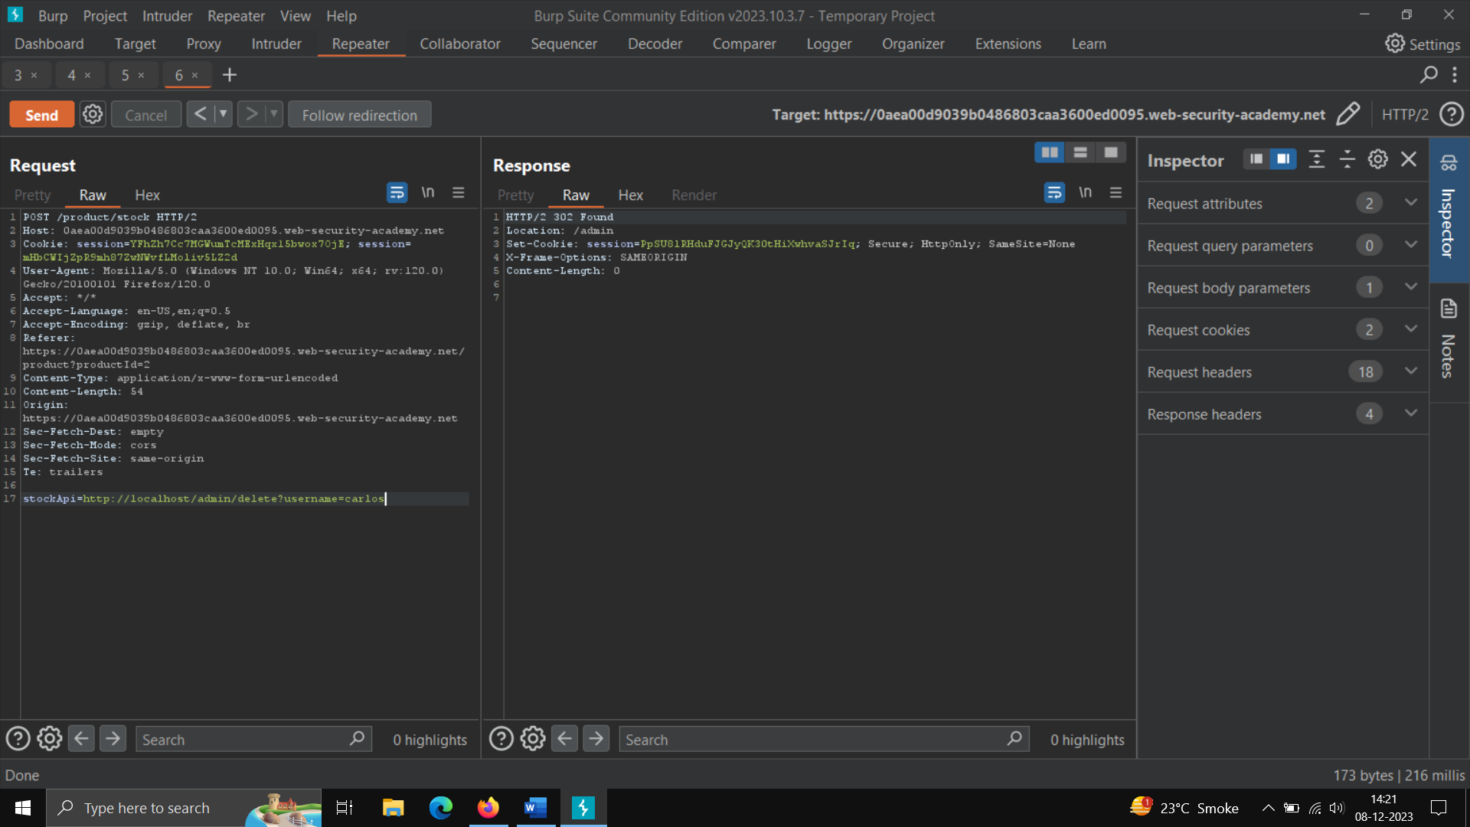

**HTML AND CSS - >**

Hypertext markup language, it is used for creating webpages, it describes the structure of a webpage, it consists of series of elements, it tell the browser, how to display the content such as heading, paragraph, link, images.

PHP -

For creating application, software it gives some understanding to create dynamic content that interacts with databases.

It includes several databases like MySQL, PostgreSQL, oracle, etc.

Characteristics of PHP-

Simplicity

Security

Flexibility

Efficiency

Familiarity

Write a program to show HELLOWORLD –

Introducing variables $_get -> an associate array of a variable passed to the current script via http get method

$_post ->

$_cookies -> it Is used for http cookie

$_session -> it is used for the current script

$_php_self -> it is used to call the php file.

PhpFunctions – A function is a piece of code which takes one or more input in the form of parameter

Commonly used function are – fopen and fclose

**Variables ->**

Integers – are whole number without any decimal point.

Doubles- are floating numbers, like3 3.242

Booleans – have only two possibles values either tur or false.

NULL- it is a special type that only has one value: NULL

Stings – are sequence of characters.

Arrays – are named and indexed as collection of values.

Objects – are instance of programmer, defined classes.

Resources- are special variables that hold to PHP.

**Operators-**

**They are used to connect two or more variables to generate result like arithmetic operations (=,-,/,%,*).**

**If else – it is used for making decision like if else, else if, switch case.**